Resort Village of Elk Ridge

January 17th, 2023 at 3:00 p.m. – Regular Meeting – Elk Ridge Resort

1. **Call to Order –** The Mayor called the meeting of Council to order.
2. **Approval of Agenda:**

MOTION: That the agenda for this meeting be approved as presented.

1. **Adoption of Minutes:**

3.1 Page 3 – Minutes of the November 29th, 2022 meeting.

MOTION: That the Minutes of the November 29th, 2022 Meeting be approved as presented.

3.2 Page 10– Minutes of the January 10th, 2023 Special meeting.

MOTION: That the Minutes of the January 10th, 2023 Special Council meeting be approved as presented.

1. **Declaration of Conflict of Interest:** None
2. **Delegations Scheduled:** None
3. **Public Hearings:**
4. **Public Acknowledgements:**
5. **Business Arising from Minutes:** None
6. **New Business:**
7. **Motions:**
8. **Administration Reports:** 
   1. Page 12-CAO Report and Updates
   2. Page 14– Municipal Revenue Sharing
   3. Page 19– Western Municipal Consulting Services
   4. Page 22– EMO Committee
   5. Page 26 - Lot Consolidation Request 92 & 93 Estates Drive
   6. Page 27 - Public Works Update
   7. Page 28 - UMAAS Spring Workshop 2023
9. **Financial Reports:**

12.1 Page 32– Financial Statements for November and December, 2022 and list of accounts to December 31, 2022.

MOTION: That Council receive and file the financial statement and list of accounts payable for November and December, 2022.

1. **Reading of Bylaw(s):** None
2. **Notice of Motion:**

**HEWETT:** Effective January 1st, 2023, the Resort Village’s waste management collection, monitoring and the servicing contract will be limited to the Waste Management Depot situated on Elk Ridge Place.

1. **Inquiries:** None
2. **In camera:**

**MOTION:** That Council move incamera to discuss the RFP submissions for legal and engineering services and purchase of former fire hall.

1. **Information Items/Correspondence:**

**17.1 –** Page 32 – Firehall letter and 2023 Fire Service Agreement.

1. **Adjournment**

Resort Village of Elk Ridge

Meeting Minutes

November 29th, 2022 Regular Meeting of Council

A Regular Meeting of Council of the Resort Village of Elk Ridge was held at the Elk Ridge Golf Resort on November 29th, 2022.

Present: Mayor Garry McKay

Councillor Trudy Engel *(via Teams Meeting)*

Councillor Ross Hewett

Councillor Margaret Smith-Windsor

Heather Scott, CAO

Absent: Councillor Ryan Danberg with regrets

1. **Call to Order –** The Mayor called the meeting of Council to order at 3:00 p.m.
2. **Approval of Agenda:**

**283-2022 HEWETT:**

That the agenda for this meeting be approved as amended.

**SECONDED:** **SMITH-WINDSOR CARRIED**

1. **Adoption of Minutes:**

3.1 Minutes of the November 10th, 2022 meeting.

**284-2022 SMITH-WINDSOR:** That the Minutes of the November 10th, 2022 Meeting be approved as presented.

**SECONDED: HEWETT CARRIED**

1. **Declaration of Conflict of Interest:** None
2. **Delegations Scheduled:** None
3. **Public Hearings:** None
4. **Public Acknowledgements:** None
5. **Business Arising from Minutes:** None
6. **New Business:** None
7. **Motions:** None
8. **Administration Reports:** 
   1. -CAO Report and Updates

**285-2022 HEWETT:** That the CAO Report for November 29, 2022 be received and filed.

**SECONDED: SMITH-WINDSOR CARRIED**

* 1. – 2023 Meeting Dates.

**286-2022 ENGEL:**

That Council set the 2023 Regular Council meeting dates on January 17; February 21; March 21; April 18; May 16; June 20; July 18; August 15; September 19; October 17; November 21; and December 19, 2023 at the Elk Ridge Resort.

**SECONDED: SMITH-WINDSOR CARRIED**

* 1. - 2023 Office Hours.

**287-2022 MCKAY:**

That the office hours for 2023 be established as Tuesday and Thursdays from 9:00 a.m. to 5:00 p.m from May 1 to September 30. and Tuesdays from 9:00 a.m. to 5:00 p.m. from October to April 30 plus additional 8 hours flex time. Any additional hours may be approved by the Mayor or designate.

**SECONDED: ENGEL** **CARRIED**

* 1. - EMO Committee.

**288-2022 HEWETT:**

That Council accept the EMO Committee Terms of Reference and direct the CAO to advertise for community members interested in sitting on the committee.

**SECONDED: ENGEL CARRIED**

1. **Financial Reports:**

12.1– Financial Statement for November 29, 2022 and List of Accounts

**289-2022 SMITH-WINDSOR:** That the November financial statement be tabled to the next regular meeting.

**SECONDED: ENGEL CARRIED**

1. **Reading of Bylaw(s):**

13.1 – Bylaw 23 – 2022 – a Bylaw to Authorize Certain Expenditures.

**290-2022 SMITH-WINDSOR:** That Bylaw 23 of 2022 a Bylaw to Authorize Certain Expenditures be introduced and read a first time.

**SECONDED: HEWETT** **CARRIED**

**291-2022 ENGEL:** That Bylaw 23 of 2022 a Bylaw to Authorize Certain Expenditures be now read a second time.

**SECONDED:** **HEWETT**  **CARRIED**

**292–2022 ENGEL:** That leave be granted for the third reading of Bylaw 23 of 2022 a Bylaw to Authorize Certain Expenditures.

**SECONDED: HEWETT** **UNANIMOUSLY CARRIED**

**293-2022 SMITH-WINDSOR:** That Bylaw 23 of 2022 a Bylaw to Authorize Certain Expenditures be read a third time and adopted.

**SECONDED:** **ENGEL**  **CARRIED**

13.2 – Bylaw 28 – 2022 – The Drainage Bylaw.

**294-2022 ENGEL:** That Bylaw 28 of 2022, The Drainage Bylaw be introduced and read a first time.

**SECONDED: HEWETT** **CARRIED**

**295-2022 HEWETT:** That Bylaw 28 of 2022 The Drainage Bylaw be now read a second time.

**SECONDED:** **SMITH-WINDSOR** **CARRIED**

**296–2022 SMITH-WINDSOR:** That leave be granted for the third reading of Bylaw 28 of 2022, The Drainage Bylaw.

**SECONDED: ENGEL** **UNANIMOUSLY CARRIED**

**297-2022 ENGEL:** That Bylaw 28 of 2022 The Drainage Bylaw be read a third time and adopted.

**SECONDED:** **HEWETT**  **CARRIED**

13.3 – Bylaw 29 of 2022 – a Bylaw to Repeal Certain Bylaws.

**298-2022 HEWETT:** That Bylaw 29 of 2022 a Bylaw to Repeal Certain Bylaws be introduced and read a first time.

**SECONDED: ENGEL** **CARRIED**

**299-2022 SMITH-WINDSOR:** That Bylaw 29 of 2022 a Bylaw to Repeal Certain Bylaws be now read a second time.

**SECONDED:** **ENGEL**  **CARRIED**

**300–2022 ENGEL:** That leave be granted for the third reading of Bylaw 29 of 2022 a Bylaw Repeal Certain Bylaws.

**SECONDED: HEWETT** **UNANIMOUSLY CARRIED**

**301-2022 SMITH-WINDSOR:** That Bylaw 29 of 2022 a Bylaw to Repeal Certain Bylaws be read a third time and adopted.

**SECONDED:** **ENGEL**  **CARRIED**

13.4 – Bylaw 30 – 2022 – a Bylaw to Regulate Public Behaviours.

**302-2022 ENGEL:** That Bylaw 30 of 2022 a Bylaw to Regulate Public Behaviours be introduced and read a first time.

**SECONDED: HEWETT** **CARRIED**

**303-2022 SMITH-WINDSOR:** That Bylaw 30 of 2022 a Bylaw to Regulate Public Behaviours be now read a second time.

**SECONDED:** **ENGEL**  **CARRIED**

**304–2022 ENGEL:** That leave be granted for the third reading of Bylaw 30 of 2022 a Bylaw to Regulate Public Behaviours.

**SECONDED: HEWETT**  **UNANIMOUSLY CARRIED**

**305-2022 HEWETT:** That Bylaw 30 of 2022 a Bylaw to Regulate Public Behaviours be read a third time and adopted.

**SECONDED:** **SMITH-WINDSOR** **CARRIED**

13.5 – Bylaw 31 – 2022 – a Bylaw to Regulate Livestock.

**306-2022 ENGEL:** That Bylaw 31 of 2022 a Bylaw to Regulate Livestock be introduced and read a first time.

**SECONDED: HEWETT**  **CARRIED**

**307-2022 HEWETT:** That Bylaw 31 of 2022 a Bylaw to Regulate Livestock be now read a second time.

**SECONDED:** **SMITH-WINDSOR** **CARRIED**

**308–2022 SMITH-WIINDSOR:** That leave be granted for the third reading of Bylaw 31 of 2022 a Bylaw to Regulate Livestock.

**SECONDED: ENGEL** **UNANIMOUSLY CARRIED**

**309-2022 ENGEL:** That Bylaw 31 of 2022 a Bylaw to Regulate Livestock be read a third time and adopted.

**SECONDED:** **HEWETT**  **CARRIED**

13.6 – Bylaw 32 – 2022 – The Noise Bylaw.

**310-2022 HEWETT:** That Bylaw 32 of 2022, The Noise Bylaw be introduced and read a first time.

**SECONDED: SMITH-WINDSOR** **CARRIED**

**311-2022 SMITH-WINDSOR:** That Bylaw 32 of 2022, The Noise Bylaw be now read a second time.

**SECONDED:** **ENGEL**  **CARRIED**

**312–2022 ENGEL:** That leave be granted for the third reading of Bylaw 32 of 2022, The Noise Bylaw.

**SECONDED: HEWETT** **UNANIMOUSLY CARRIED**

**313-2022 HEWETT:** That Bylaw 32 of 2022, The Noise Bylaw be read a third time and adopted.

**SECONDED:** **SMITH-WINDSOR** **CARRIED**

1. **Notice of Motion:**

14.1 – Notice of Motion Re: Waste Management Depot.

**313-2022 SMITH-WINDSOR:** That Council waive notice for the following motion:

***“****Effective January 1, 2023, the Resort Village’s waste management collection, monitoring and the servicing contract will be limited to the Waste Management Depot situated on Elk Ridge Place.”*

**SECONDED: ENGEL CARRIED**

**314 – 2022 SMITH-WINDSOR:** Effective January 1, 2023, the Resort Village’s waste management collection, monitoring and servicing contract will be limited to the Waste Management Depot situated on Elk Ridge Place.

**SECONDED: ENGEL WITHDRAWN**

**315-2022 ENGEL:** That the following Motion be tabled to the January meeting:

*“Effective January 1, 2023, the Resort Village’s waste management collection, monitoring and the servicing contract will be limited to the Waste Management Depot situated on Elk Ridge Place.”*

**SECONDED: MCKAY CARRIED**

14.2 - Notice of Motion Bylaw 27 of 2022, the Open Air Fire Bylaw.

SMITH-WINDSOR: Bylaw amendment to Bylaw 27 of 2022 Schedule amendment for next

meeting.

1. **Inquiries:** None
2. **In camera:**

**316-2022 SMITH-WINDSOR:** That Council move to incamera session to discuss purchase of the former fire hall and snow clearing draft Memorandum of Understanding at 5:04 p.m.

**SECONDED: HEWETT CARRIED**

Present: Mayor McKay, Councilor Engel, Councilor Hewett, Councilor Smith-Windsor and CAO Heather Scott.

**317-2022 HEWETT:** That Council resume open Council meeting at 5:25 p.m.

**SECONDED: ENGEL CARRIED**

1. **Information Items/Correspondence:** None
2. **Adjournment**

**318-2022 MCKAY:** That the meeting adjourn at 5:26 p.m.

**SECONDED: SMITH-WINDSOR**  **CARRIED**

**_____________________________ ___________________________**

**Mayor CAO**

Resort Village of Elk Ridge

Meeting Agenda

January 10th, 2023 at 3:00 p.m. – Special Council Meeting -White Tail Room

1. **Call to Order –** The Mayor called the meeting of Council to order.
2. **Approval of Agenda:**

**01-2023 SMITH-WINDSOR:** That the agenda for this meeting be approved as presented.

**SECONDED: ENGEL CARRIED**

1. **Adoption of Minutes:** None
2. **Declaration of Conflict of Interest:** None
3. **Delegations Scheduled:** None
4. **Public Hearings:** None
5. **Public Acknowledgments:** None
6. **Business Arising from Minutes:** None
7. **New Business:** None
8. **Motions:** None
9. **Administration Reports:** None
10. **Financial Reports:** None
11. **Reading of Bylaws:** None
12. **Notice of Motion:** N/A
13. **Inquiries:**
14. **Incamera:**

**02-2023 HEWETT:** That Council move incamera for the purposes of discussing Strategic Planning at 3:11 p.m. Hewett:

**SECONDED:** **DANBERG CARRIED**

Present: Mayor McKay, Councilor Engel, Councilor Hewett, Councilor Smith-Windsor and CAO Heather Scott.

* 1. **DANBERG:** That Council resume open Council meeting at 4:59 a.m.

**ECONDED: ENGEL CARRIED**

1. **Information Item/Correspondence:** None
2. **Adjournment**

**004-2023 SMITH-WINDSOR:** That the meeting adjourn at 5:01 p.m.

**SECONDED:** **HEWETT CARRIED**

**DECISION ITEM**

|  |  |
| --- | --- |
| **Subject** | Municipal Revenue Sharing Declaration |
| **Council Meeting Date Presented:** | December 20, 2022 |
| **Agenda Item:** | 11.2 |
| **Prepared By:** | Heather Scott CAO |

|  |
| --- |
| BACKGROUND:   * Each year all municipalities in Saskatchewan have certain requirements they must meet in order to be eligible for the Municipal Revenue Sharing Grant Funding, these include:   1.       Submission of the Audited Annual Financial Statement to the ministry;  2.       Submission of the Public Reporting on Municipal Waterworks to the ministry *(if applicable)*;  3.       In Good Standing with respect to the reporting and remittance of Education Property Taxes (see Declaration of Eligibility Guide for definition);  4.       Adoption of a Council Procedures Bylaw;  5.       Adoption of an Employee Code of Conduct; and  6.       All members of council have filed and annually updated their Public Disclosure Statements, as required.   * Municipalities must annually report their compliance with the eligibility requirements to the Ministry of Government Relations (ministry) by completing an online Declaration of Eligibility (declaration). * The declaration can be completed online, but must be done prior to January 31, 2023. * Because the Resort Village of Elk Ridge was incorporated in 2022, two of the requirements do not apply, these are:  1. Submission of the 2021 Audited Financial Statement; and 2. Submission of the 2021 Public Reporting on Waterworks. |
| **BUDGET & OTHER CONSIDERATIONS:**   * Approximately $30,101 in grant funding. |
| **RECOMMENDATION:**   * That Council make the necessary declaration motion for remittance prior to the end of January, 2023. |
| **PROPOSED MOTION:**  The Council of the Resort Village of Elk Ridge confirms the municipality meets the following eligibility requirements to receive the Municipal Revenue Sharing grant:  • Being that the municipality was incorporated on January 1, 2022, we are exempt from having to remit our 2021 Audited Financial Statements to the Ministry of Government Relations;  • The municipality does not run a Municipal Waterworks System;   * In Good Standing with respect to the reporting and remittance of Education Property Taxes;   • Adoption of a Council Procedures Bylaw;  • Adoption of an Employee Code of Conduct; and  • All members of council have filed and annually updated their Public Disclosure Statements, as required;  That we authorize the Administratorto sign the Declaration of Eligibility and submit it to the Ministry of Government Relations. |
| **Respectfully Submitted by: Heather Scott, CAO** |
|  |

**DECISION ITEM**

|  |  |
| --- | --- |
| **Subject** | Board of Revision and Development Appeals Board Appointments |
| **Council Meeting Date Presented:** | January 17, 2023 |
| **Agenda Item:** | 11.3 |
| **Prepared By:** | Heather Scott CAO |

|  |
| --- |
| BACKGROUND:   * In 2022, Council resolved to contract Western Municipal Consulting to provide Board of Revision and Development Appeals Board Services. * We didn’t require any Development Appeals in 2022 and only had three Board of Revision Appeals resulting in $300 fee for service. Also a retainer of $425 was paid for 2022 services. * Western Municipal Consulting has reached out to renew services for 2023. * To continue contracting with WMC for 2023, they require a new motions of council appointing them as Board of Revision and Development Appeals Board as well as appointing the Secretaries for the Board. * In 2022 all companies that provide these services in the province were contacted for costing and information prior to Council appointing Western Municipal Services. There doesn’t appear to be any new companies that provide similar services since last year. |
| **BUDGET & OTHER CONSIDERATIONS:**  Retainer $450 plus tax. Other Rates charged if required:  STAFFING HOURLY RATES  Secretary: $50.00/hour  Senior Consultant: $90.00/hour  Board Member: $90.00/hour  ADDITIONAL RATES  Electronic Venue Cost: $20.00/appeal  In-person Venue Cost: Varies with Location  Printing (i.e., paper, envelopes, etc.): $0.15/page  Postage: At Cost  Mileage: $0.60/km/staff |
| **RECOMMENDATION:**   * That the Resort Village of Elk Ridge continue to engage the services of Western Municipal Consulting for Board of Revision and Board of Appeal services for 2023. |
| **PROPOSED MOTIONS:**   1. That the RESORT VILLAGE OF ELK RIDGE appoints Western Municipal Consulting Ltd. to manage the Board of Revision process for the term of January 1, 2023, through to December 31, 2023; remuneration as set out in Western Municipal Consulting Ltd. fee schedule, with the following to serve as Members of the Board of Revision: Tim Lafreniere, Mike Waschuk, Gordon Parkinson, Dave Thompson, Wayne Adams, Jeff Hutton, Dave Gurnsey, Murray Dean, and Stew Demmans.   The Chair shall be responsible for naming no fewer than three (3) members for the hearing of any matter. Where the Chair does not include themselves among the appointees, the members appointed for a hearing shall determine the chair of that hearing from among their numbers.   1. That the RESORT VILLAGE OF ELK RIDGE appoints Liana Stepan with Western Municipal Consulting Ltd. as Secretary to the Board of Revision for the term of January 1, 2023, through to December 31, 2023; remuneration as set out in Western Municipal Consulting Ltd. fee schedule. If Liana Stepan is unable to perform secretarial functions for reasons which may include scheduling difficulties the secretary may appoint a delegate to perform administrative functions and may appoint a recording secretary for the purposes of any hearing. 2. That the RESORT VILLAGE OF ELK RIDGE appoints Western Municipal Consulting Ltd. to manage the Development Appeals Board process for the term of January 1, 2023, through to December 31, 2023; remuneration as set out in Western Municipal Consulting Ltd. fee schedule, with the following to serve as Members of the Development Appeals Board: Tim Lafreniere, Mike Waschuk, Gordon Parkinson, Dave Thompson, Wayne Adams, Jeff Hutton, Barry Clark, Dave Gurnsey, Murray Dean, Pam Malach, Stew Demmans, and Stu Hayward.   3   1. That the RESORT VILLAGE OF ELK RIDGE appoints Claudette McGuire with Western Municipal Consulting Ltd. as Secretary to the Development Appeals Board for the term of January 1, 2023, through to December 31, 2023; remuneration as set out in Western Municipal Consulting Ltd. fee schedule. If Claudette McGuire is unable to perform secretarial functions for reasons which may include scheduling difficulties the secretary may appoint a delegate to perform administrative functions and may appoint a recording secretary for the purposes of any hearing. |
| **Respectfully Submitted by: Heather Scott, CAO** |
|  |







**DECISION ITEM**

|  |  |
| --- | --- |
| **Subject** | Establishment of EMO Committee |
| **Council Meeting Date Presented:** | December 17, 2022 |
| **Agenda Item:** | 11.4 |
| **Prepared By:** | Heather Scott CAO |

|  |
| --- |
| BACKGROUND:   * "In Saskatchewan, municipalities are obligated to establish emergency plans by The Emergency Planning Act, 1989 which also gives council the responsibility for the direction and control of a municipal emergency response in order to take action to implement the plan and to protect the property, health, safety and welfare of the public." - Government of Saskatchewan, Saskatchewan.ca, Web. * EMO Committees are typically made up of members of the community as well as representatives from Council. * Two community members put their names forward on the community survey indicating that they would be interested in participating in EMO. * At the November 29th, 2022 meeting of Council, Council resolved the following:   **288-2022 HEWETT:**  That Council accept the EMO Committee Terms of Reference and direct the CAO to advertise for community members interested in sitting on the committee.  **SECONDED: ENGEL CARRIED**  Administration posted a notice requesting volunteers for the newly established EMO Committee as well as contacted the interested parties from the community survey.   * The two community members who expressed interest in the committee were also contacted to see if they were still interested in sitting on the board. One person was unavailable at present but may be in the future. The other, Rod Orieux, was still interested and ask that his name be brought forward. |
| **BUDGET & OTHER CONSIDERATIONS:**   * Possible future costs to hire professionals to assist with EMO Plan development. Ie. $1500 was previously budgeted in 2022. |
| **RECOMMENDATION:**   * That Council appoint Rod Orieux to the EMO Committee and also appoint interested Council member(s) to the committee. |
| **PROPOSED MOTION:**   * That Council appoint Rod Orieux and Councilor _______________ as members of the EMO Committee. |
| **Respectfully Submitted by: Heather Scott, CAO** |
|  |

 RESORT VILLAGE OF ELK RIDGE

TERMS OF REFERENCE

EMERGENCY MEASURES OPERATIONS COMMITEE

PURPOSE:

To oversee the creation and implementation of an EMO Plan for the community.

GOVERNANCE:

The Committee is responsible to Council.

MEMBERS:

1. Councilor Danberg

2. Councilor

3. Rod Orieux

4. Community Member

FUNCTION:

To provide support and direction to the CAO on matters dealing with emergency measures operations in the Resort Village of Elk Ridge.

MEETINGS:

As required

**DECISION ITEM**

|  |  |
| --- | --- |
| **Subject** | Lot Consolidation Request 92 and 93 Estates Drive |
| **Council Meeting Date Presented:** | December 20, 2022 |
| **Agenda Item:** | 11.5 |
| **Prepared By:** | Heather Scott CAO |

|  |
| --- |
| BACKGROUND:   * The owners of 92 & 93 have requested permission to consolidate their lots to enable them to build a single unit dwelling over the consolidated lots. * Council can consider granting permission for lots to be consolidated on a case by case basis provided that they are adjoining, the titles for both lots are in the same owner’s names and the consolidation would not affect any adjacent properties or roadways. * The lots being requested are located adjacent to each other and share the same owner’s names on title. The purpose for the consolidation is for a residential dwelling to be constructed across the two lots. * If Council approval is granted, the owners would still be required to register the consolidation with ISC to make the consolidation valid. * There could be a potential change to the taxes assessed on a consolidated lot. If there is a base tax being applied, it would then only be applied to one property. However, the properties assessed value would change to reflect the larger lot size. |
| **BUDGET & OTHER CONSIDERATIONS:**   * Possible change in tax levy for the property based on the loss of base tax ($200/property in 2022) but increase mill rate levy due to higher assessed value of larger parcel. |
| **RECOMMENDATION:**   * Administration sees no issue with the consolidation being proposed. * It is recommended to put a timeline on any approvals to ensure that the proper registration is completed with ISC. |
| **PROPOSED MOTION:**  That Council approve the request of Ken & Lynne Wilde for the consolidation of Unit 92 Plan 99PA 21324 and Unit 93 Plan 99PA21324 with civic addresses of 92 and 93 Estates Drive conditional on the consolidation being registered with ISC prior to the 15th of March, 2023. |
| **Respectfully Submitted by: Heather Scott, CAO** |
|  |

**Request to consolidate lots 92 and 93**

Ken & Lynne Wilde

2023-01-01 10:17 PM

To: Heather Scott

Hi Heather,

Happy New Year!   Hope you had a great Christmas.   We’re up here in Waskesiu right now, and the weather has been amazing.   So much beauty to take in!

As per my previous email, we would like permission for the consolidations of our lots, 92 Estates Drive and 93 Estates DrI’ve for the purpose of building a single unit residence on the consolidated lot.

We have begun the design process of this new build, and look forward to taking the next steps that are required to make this a reality.

Please let us know if you require any other information.

Thank you!

Ken Wilde and Lynne Sandmeyer

Sent from my iPhone

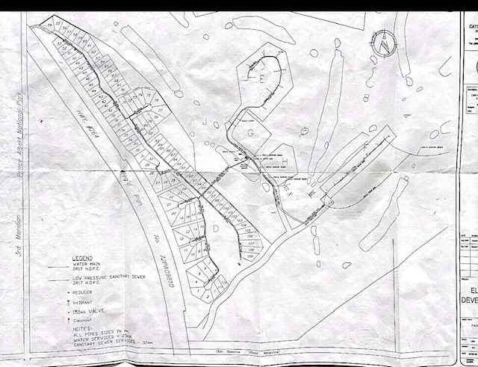

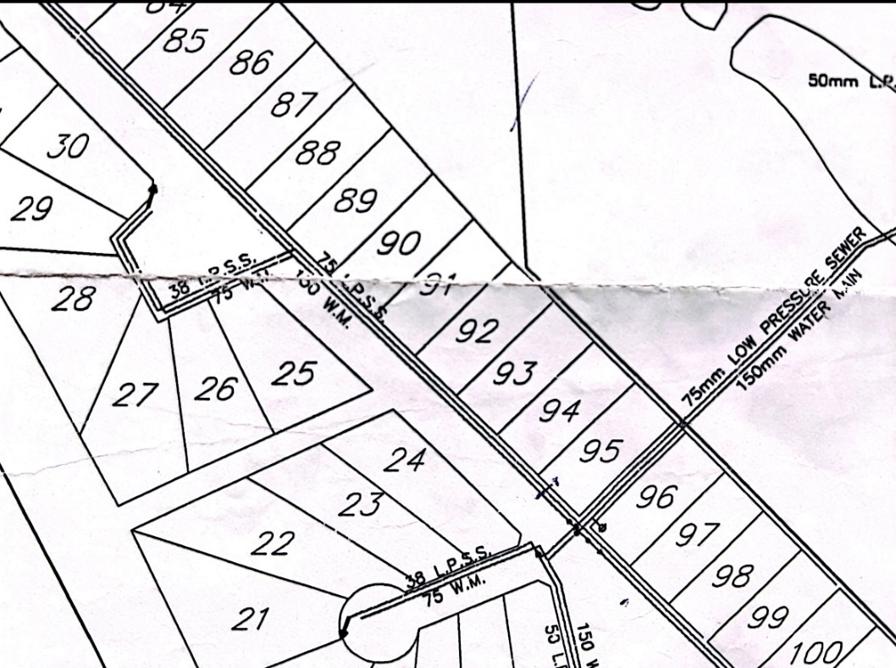

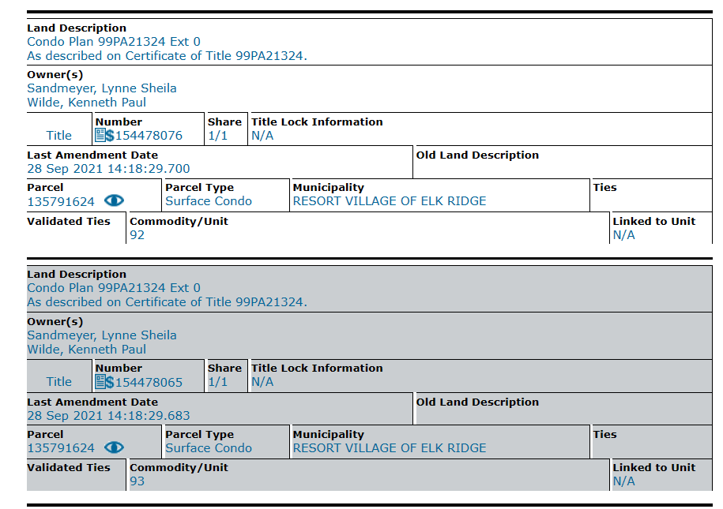

**RESORT VILLAGE OF ELK RIDGE**

**PUBLIC WORKS COMMITTEE ACTION PLAN**

|  |  |  |  |  |
| --- | --- | --- | --- | --- |
| A | Roads – Snow Removal | * Update Winter Road Policy with condo corps   Meet with Estates Board?   * Get contractor quotes * Recommend contractor * Finalize contract |  | Sept. 2023  Pending?  Comp.  Comp.  ? |
| A | Addressing – Postal Code & Boxes | * Provide requested data to Canada Post | CAO | Comp. |
| * Pressure Member of Parliament to create sense of urgency for Postal Code and local PO boxes | RH | Comp. |
| A | Drainage | * Get input from engineering contacts * Recommend grant application * Prepare grant application | CAO | Passed info. to Estates Board |
| A | Website | * Compile newcomer’s content | MSW | Comp. |
| A | Waste Management | * Get contractor quotes * Recommend contractor * Finalize contract | CAO | Comp.  Comp.  ? |
| A | Recycling | * Get contractor quotes * Recommend contractor * Finalize contract | CAO | Comp.  Comp.  ? |
| B | Addressing - CARS | * Follow-up with agencies not using CARS for RVER | CAO | Comp. |
| B | Roads – Pavement Repairs | * Budget approval for study * Hire engineer | Com. | Jan/ 2023  Spring |
| B | Waste Management | * RV Park solution (Darcy). * Motion to chg. fees * Bin #7 motion pending. | Com.  Com.  Com. | pending |
| C | Network Communications | * Pressure SaskTel for internet speed upgrades | RH | Dec |
| C | Land | * Lease/easemt.Waste depot | Com. | Feb. 2023 |
| C | Aurora Huts | * Explore opportunity with R2SK | MSW | Feb. ‘23 |
| C | Lighting | * LED upgrading | CAO | Feb. ‘23 |

**DECISION ITEM**

|  |  |
| --- | --- |
| **Subject** | UMAAS Spring Workshop |
| **Council Meeting Date Presented:** | January 10, 2023 |
| **Agenda Item:** | 11.6 |
| **Prepared By:** | Heather Scott CAO |

|  |
| --- |
| BACKGROUND:   * The RMAA and UMAAS have partnered to host a Spring workshop for administrators to go over some municipal updates and changes to legislation being presented in 3 modules. * Module 1: Overview of EMAP (Emergency Management Assistance Program) * Module 2: Municipal Creation/Alteration/ Restructuring * Module 3: Ministry of Government Relations * The workshop in our area is being held on March 23, 2023 in Prince Albert. |
| **BUDGET & OTHER CONSIDERATIONS:**   * The cost for this workshop is $100 plus travel at 89km each way or 178 km round trip approximately $108.58. |
| **RECOMMENDATION:**   * As these workshops generally contain a lot of important updates and information with the opportunity to ask questions and interact face-to-face with members of Advisory Services, it would be a good opportunity and is recommended the CAO be allowed to attend. |
| **PROPOSED MOTION:**  That Council approve the attendance of the CAO at the RMAA/UMAAS Spring Workshop being held March 23, 2023 at a cost of $100 plus mileage. |
| **Respectfully Submitted by: Heather Scott, CAO** |
|  |
|  |

