Resort Village of Elk Ridge

Meeting Agenda

July 12th, 2022 at 3:00 p.m. – Regular Meeting – Elk Ridge Golf Resort

1. **Call to Order –** The Mayor called the meeting of Council to order.
2. **Delegations:** None
3. **Approval of Agenda:**

**ENGEL agenda additions.**

MSW OTION: That the agenda for this meeting be approved as presented.

1. **Public Hearings:** None
2. **Reading of Bylaws:** None
3. **Adoption of Minutes:**

6.1 Page 3– Minutes of the June 14th, 2022 meeting.

HEWETT: That the Minutes of the June 14th, 2022 Meeting be approved as presented.

1. **Business Arising from Minutes:** None
2. **Action/Motion Items:**
   1. Page 7- Transition Committee Bylaw Recommendations.

ENGEL: Adopt transition committee minutes of Jun 14, 2022. CARRIED

1. **Administration Reports:**

9.1 Page 12 -CAO Report and Updates

1. **Accounts for Payment:**
2. **Financial Statements:**
   1. Page 13– Financial Statement for June, Bank Reconciliation and List of Accounts

MOTION: That Council receive and file the financial statement, bank reconciliation and list of accounts payable for June, 2022.

1. **Council Divisional Reports:** N/A
2. **New Business**:

**13.1**

1. **Incamera:**
2. **Correspondence:**
3. **Other Business:**
4. **Adjournment**

Resort Village of Elk Ridge

Meeting Minutes

June 14th, 2022 Regular Meeting of Council

A Regular Meeting of Council of the Resort Village of Elk Ridge was held at the Elk Ridge Golf Resort on June 14th, 2022

Present: Mayor Garry McKay

Councillor Ryan Danberg

Councillor Trudy Engel (*via teams meeting)*

Councillor Ross Hewett

Councillor Margaret Smith-Windsor

Heather Scott, CAO

1. **Call to Order –** With a quorum being present, Mayor Garry McKay called the meeting to order at 3:00 p.m.
2. **Delegations:** Fire Chief Chris McShannock and John Stauffer, Lakeland District Fire Department.
3. **Approval of Agenda:**

**111-2022 SMITH-WINDSOR:** That the agenda for this meeting be approved as amended with two additional items:

1. 8.4 – Fire Agreement;
2. 8.2 – Budget dated June 14, 2022 **CARRIED**
3. **Public Hearings:** None
4. **Reading of Bylaws:** None
5. **Adoption of Minutes:**

6.1 - Minutes of the May 10th, 2022 Council Meeting.

**112 – 2022 HEWETT:** That the Minutes of the May 10th, 2022 Council Meeting be approved as presented.  **CARRIED**

6.2 – Minutes of May 24th, 2022 Special Council Meeting.

**113-2022 ENGEL:** That the Minutes of the May 24th, 2022 Special Meeting be approved as presented. **CARRIED**

6.3 – Minutes of the June 7th, 2022 Special Council Meeting.

**114 – 2022 SMITH-WINDSOR:** That the Minutes of the June 7th, 2022 Special Meeting be approved as presented. **CARRIED**

1. **Business Arising from Minutes:** None
2. **Action/Motion Items:**

8.1 – Governance Training.

**115-2022 SMITH-WINDSOR:** That Council direct administration to schedule governance training through Saskatchewan Ministry of Government Relations.

**CARRIED**

8.2 – 2022 Budget Report.

**116-2022 MCKAY:** That the June 14, 2022 Budget be amended by adding $5,000 to GL 530-460-110 Snow Removal.  **CARRIED**

**117-2022 HEWETT:** That a reserve transfer be added to the June 14, 2022 budget to offset the 2021 expenses of $10,768. **CARRIED**

**118-2022 DANBERG:** That Council approve the 2022 budget as amended and consider three readings of Bylaw 10-2022 – The Fire Service Levy Bylaw, 24-2022 – the Base Tax Bylaw, Bylaw 25-2022 – The Mill Rate Bylaw and Bylaw 26-2022 the Sanitation Levy Bylaw.

**CARRIED**

**119-2022 ENGEL:**  That Bylaw 10 of 2022 a Bylaw to set a Fire Service Levy be introduced and read a first time.  **CARRIED**

**120-2022 SMITH-WINDSOR:** That Bylaw 10 of 2022 a Bylaw set a Fire Service Levy be amended by adding the word “improved” before the word “property”.

**CARRIED**

**121-2022 SMITH-WINDSOR:** That Bylaw 10 of 2022 as amended a Bylaw to set a Fire Service Levy be now read a second time. **CARRIED**

**122-2022 ENGEL:** That leave be granted for third reading of Bylaw 10 of 2022 as amended a Bylaw to set a Fire Service Levy. **UNANIMOUSLY CARRIED**

**123-2022 SMITH-WINDSOR:** that Bylaw 10 of 2022 as amended a Bylaw to set a Fire Service Levy be read a third time and adopted. **CARRIED**

**124-2022 DANBERG:**  That Bylaw 24 of 2022 a Bylaw to set a Base Tax be introduced and read a first time.  **CARRIED**

**125-2022 HEWETT** That Bylaw 24 of 2022 a Bylaw set a Base Tax be amended by adding the “100” under Commercial & Industrial Improvements and “200” under Commercial & Industrial Land & Improvements.  **CARRIED**

**126-2022 HEWETT:** That Bylaw 24 of 2022 as amended a Bylaw to set a Base Tax be now read a second time. **CARRIED**

**127-2022**  **SMITH-WINDSOR:** That leave be granted for third reading of Bylaw 24 of 2022 as amended a Bylaw to set a Base Tax. **UNANIMOUSLY CARRIED**

**128-2022 ENGEL:** that Bylaw 24 of 2022 as amended a Bylaw to set a Base Tax be read a third time and adopted. **CARRIED**

**129-2022 DANBERG:**  That Bylaw 25 of 2022 a Bylaw to set the 2022 Mill Rates be introduced and read a first time.  **CARRIED**

**130-2022 HEWETT:** That Bylaw 25 of 2022 a Bylaw to set the 2022 Mill Rates be now read a second time. **CARRIED**

**131-2022 SMITH-WINDSOR:** That leave be granted for third reading of Bylaw 25 of 2022 a Bylaw to set the 2022 Mill Rates. **UNANIMOUSLY CARRIED**

**132-2022 ENGEL:** that Bylaw 25 of 2022 a Bylaw to set the 2022 Mill Rates be read a third time and adopted. **CARRIED**

**133-2022 DANBERG:**  That Bylaw 26 of 2022 a Bylaw to set a Sanitation Levy be introduced and read a first time.  **CARRIED**

**134-2022 HEWETT:** That Bylaw 26 of 2022 a Bylaw set Sanitation Levy be amended by adding the word “improved” before the words “every taxable property”.

**CARRIED**

**135-2022 HEWTT:** That Bylaw 26 of 2022 as amended a Bylaw to set a Sanitation Levy be now read a second time. **CARRIED**

**136-2022 SMITH-WINDSOR:**  That leave be granted for third reading of Bylaw 26 of 2022 as amended a Bylaw to set a Sanitation Levy. **UNANIMOUSLY CARRIED**

**137-2022 ENGEL:** that Bylaw 26 of 2022 as amended a Bylaw to set a Sanitation Levy be read a third time and adopted. **CARRIED**

* 1. – PARCS Convention.

**138-2022 DANBERG:** That the 2022 PARCS Convention Invitation be received and filed. **CARRIED**

* 1. – Fire Service Agreement.

**139-2022 DANBERG:** That Council authorize signature of the Agreement for Fire Service with the Lakeland & District Fire Department. **CARRIED**

1. **Administration Reports:** 
   1. CAO Report and Updates.

*Councilor Danberg left at 4:31 p.m.*

**140-2022 ENGEL:** That Council receive and file the CAO report for June, 2022.

**CARRIED**

*Councilor Danberg returned at 4:35 p.m.*

1. **Accounts for Payment:** N/A
2. **Financial Statements:**

11.1 Financial Statement for May 2022, Bank Reconciliation and List of Accounts.

**141-2022 ENGEL:**

That Council receive and file the financial statement, bank reconciliation and list of accounts payable for May, 2022. **CARRIED**

1. **Council Divisional Reports:** N/A
2. **New Business:** None
3. **Incamera:** N/A
4. **Correspondence:**

15.1 – EMO Outline provided by Leslie Tuchek.

**142 – 2022 SMITH-WINDSOR:** That Council authorize the engagement of Leslie Tuchek to facilitate EMO setup at the Resort Village of Elk Ridge. **CARRIED**

1. **Other Business: None**
2. **Adjournment:**

**145-2022 HEWETT:** That the meeting adjourn 4:46 p.m. **CARRIED**

**_____________________________ ___________________________**

**Mayor CAO**

**DECISION ITEM**

|  |  |
| --- | --- |
| **Subject** | Transition Committee Bylaw Recommendations |
| **Council Meeting Date Presented:** | June 30, 2022 |
| **Agenda Item:** | 8.1 |
| **Prepared By:** | Heather Scott CAO |

|  |
| --- |
| **BACKGROUND:**   * At the June 14, 2022 the Transition Advisory Committee held a follow up bylaw review meeting. Several bylaws were finalized with direction to refer these bylaws to Council for consideration at their next meeting. * These bylaws include:   1. Bylaw 03 – 2022 Code of Ethics Bylaw;   2. Bylaw 04 – 2022 Administrative Bylaw;   3. Bylaw 06 – 2022 Tax Certificates and Assessment and Tax Bylaw;   4. Bylaw 08 – 2022 Nuisance Abatement Bylaw;   5. Bylaw 11 – 2022 Dispense with Mailing of Assessment Notices Bylaw;   6. Bylaw 13 – 2022 Trailer License Fee Bylaw;   7. Bylaw 14 – 2022 Public Notice Bylaw;   8. Bylaw 16 – 2022 Employee Code of Conduct   9. Bylaw 17- 2022 Civic Address Bylaw;   10. Bylaw 18 – 2022 Animal Control Bylaw;   11. Bylaw 20 – 2022 Establish EMO Bylaw;   12. Bylaw 21 – 2022 Sewage Disposal Bylaw;   13. Bylaw 22 – 2022 Waste Collection & Recyclable Bylaw. * The draft bylaws will be included as separate attachments due to past formatting issues. * The Minutes of the June 14th, 2022 Transition Advisory Committee are also attached for approval. |
| **BUDGET & OTHER CONSIDERATIONS:**   * Revenue for fees and services as set by bylaws * Revenue for fines as set by bylaws. |

|  |
| --- |
| **RECOMMENDATION:**   * That Council approve the recommendation of the Transition Advisory Committee and place each bylaw on the agenda for three readings. |
| **PROPOSED MOTION:**  That Council receive and file the Transition Advisory Committee Minutes of June 14, 2022 and that the following bylaws be placed on the agenda for consideration of three readings:   * 1. Bylaw 03 – 2022 Code of Ethics Bylaw;   2. Bylaw 04 – 2022 Administrative Bylaw;   3. Bylaw 06 – 2022 Tax Certificates and Assessment and Tax Bylaw;   4. Bylaw 08 – 2022 Nuisance Abatement Bylaw;   5. Bylaw 11 – 2022 Dispense with Mailing of Assessment Notices Bylaw;   6. Bylaw 13 – 2022 Trailer License Fee Bylaw;   7. Bylaw 14 – 2022 Public Notice Bylaw;   8. Bylaw 16 – 2022 Employee Code of Conduct   9. Bylaw 17- 2022 Civic Address Bylaw;   10. Bylaw 18 – 2022 Animal Control Bylaw;   11. Bylaw 20 – 2022 Establish EMO Bylaw;   12. Bylaw 21 – 2022 Sewage Disposal Bylaw;   13. Bylaw 22 – 2022 Waste Collection & Recyclable Bylaw. |
| **Respectfully Submitted by: Heather Scott, CAO** |

Transition Advisory Committee

Meeting Minutes

June 14, 2022 at Elk Ridge Resort

Present: Mayor Garry McKay

Councillor Ryan Danberg

Councillor Trudy Engel *(via Teams Meeting)*

Councillor Ross Hewett

Councillor Margaret Smith-Windsor

Heather Scott, CAO

1. **Call to Order –** The Chair called the meeting of the Transition Advisory Committee to order at 4:47 p.m.
2. **Delegations: N/A**
3. **Approval of Agenda:**

**SMITH-WINDSOR:** That the agenda for this meeting be approved as presented. **CARRIED**

1. **Adoption of Minutes:**

**4.1**  -Minutes of April 12, 2022 meeting.

**HEWETT:** That the Minutes of the April 12, 2022 Transition Committee be approved as presented.  **CARRIED**

1. **Business Arising from Minutes:**

5.1  Bylaw Review:

Bylaws Referred back to committee for further discussion from May 10, 2022 Council meeting:

**ENGEL:** That the following Bylaws be recommended for approval at the next regular Council meeting:

* + - 1. Bylaw 03 – 2022 Code of Ethics Bylaw;
      2. Bylaw 04 – 2022 Administrative Bylaw;
      3. Bylaw 06 – 2022 Tax Certificates and Assessment and Tax Bylaw;
      4. Bylaw 08 – 2022 Nuisance Abatement Bylaw;
      5. Bylaw 11 – 2022 Dispense with Mailing of Assessment Notices Bylaw;
      6. Bylaw 13 – 2022 Trailer License Fee Bylaw;
      7. Bylaw 14 – 2022 Public Notice Bylaw;
      8. Bylaw 16 – 2022 Employee Code of Conduct
      9. Bylaw 17- 2022 Civic Address Bylaw;
      10. Bylaw 18 – 2022 Animal Control Bylaw;
      11. Bylaw 20 – 2022 Establish EMO Bylaw;
      12. Bylaw 21 – 2022 Sewage Disposal Bylaw;
      13. Bylaw 22 – 2022 Waste Collection & Recyclable Bylaw. **CARRIED**

*T. Engel left the meeting at 5:09 p.m.*

Bylaws referred back from April 25, 2022 Transition Committee Meeting:

1. Bylaw 10 – 2022 Fire Special Levy Bylaw;
2. Bylaw 12 – 2022 Traffic Bylaw;
3. Bylaw 15 – 2022 Council Procedure Bylaw;

New Assigned Bylaws for Review:

1. Bylaw 27-2022 – Open Fire Bylaw.
2. Building Bylaw
3. Drainage Bylaw
4. **Assignment of additional bylaws for review.** Updated progress chart sent out
5. **Action/Motion Items: N/A**
6. **Correspondence: N/A**
7. **Other Business:**

9.1 Bylaws to Rescind/Expire:

* ISC Agreement Bylaw
* Board of Revision Bylaw
* ATV Bylaws 10 & 16
* Library Agreement Bylaw
* Parking Bylaw
* Business License Bylaw
* Inter-municipal Business License Bylaw
* Tire Bylaw

1. **Adjournment:**

DANBERG: That the meeting adjourn at 5:23 p.m. **CARRIED**

**_______________________________ ______________________________**

**Chairperson CAO**

Administrator Report – July 12, 2022

* There have been 5 building permits issued so far this year. 4 for principal dwellings and one for a detached garage. There are also 4 other pending permits at various stages.
* The tax payments are coming into the office very quickly. The payments are primarily split between Etransfers and cheques with a few cash payments. 7 customers have signed up for CAFT tax payments so far. There were a few who mistakenly paid their taxes to the District and those will be sent on to Elk Ridge for processing.
* Administration has received permission for the installation of a locked mailbox near the municipal office door. This will assist any ratepayers wanting to drop anything off out of office hours.
* I have been working with Councilor Smith-Windsor on a survey for the community BBQ. This survey will available in hard copy but can also be emailed to everyone on the ERCOA list so that we can ensure that it reaches as many community members as possible. The date and time set for the BBQ is July 29th from 3:00 p.m. – 6:00 p.m.
* Judy Kanak has replied regarding governance education sessions with administration and council. She has indicated that the session would last one whole day from 9:00 a.m. – 4:00 p.m. with one hour break for lunch. I am hoping to schedule this in August sometime on a day that works for everyone.
* The Assessment Return has been received and I am working on getting it back to SAMA next week.
* Greenland Waste has sent an email requesting to come to the August council meeting as a delegation.
* The waste and recycling bins will need to be reviewed with some decisions made by Council. The condo area would like an extra bin as they are filling the one that they have. There have also been questions on why there aren’t more bins open for use. Lastly, the issues with contractor construction materials being dumped in the bins and how to monitor the bins and deter unwanted materials from being put in them.
* The line painting was delayed from June due to rain and scheduling. I have followed up with Highways who has plans to complete the job on Monday, July 11, 2022.



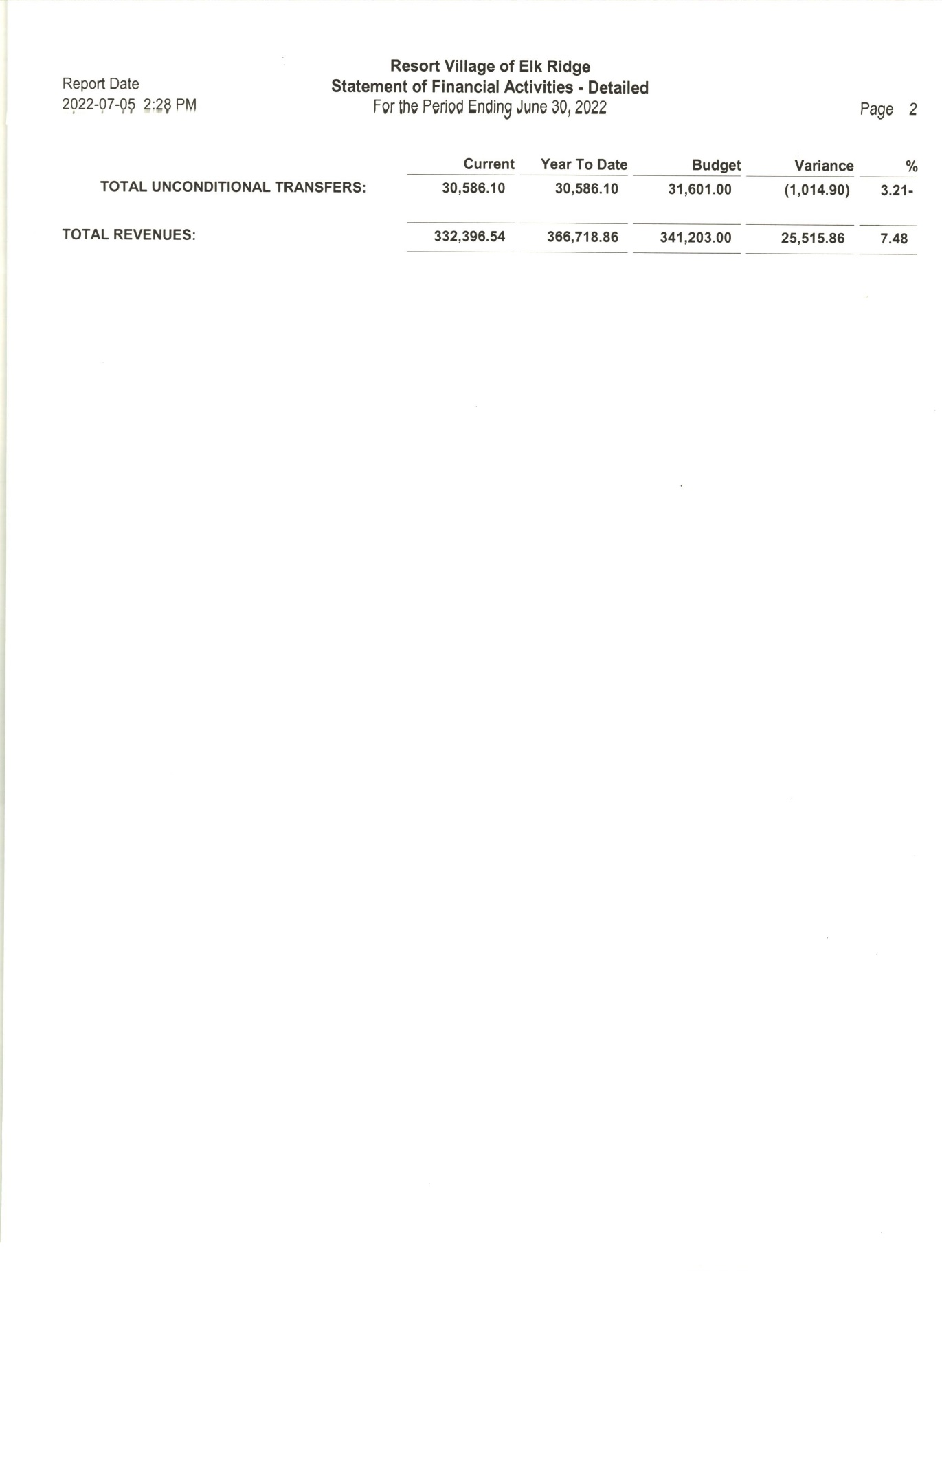

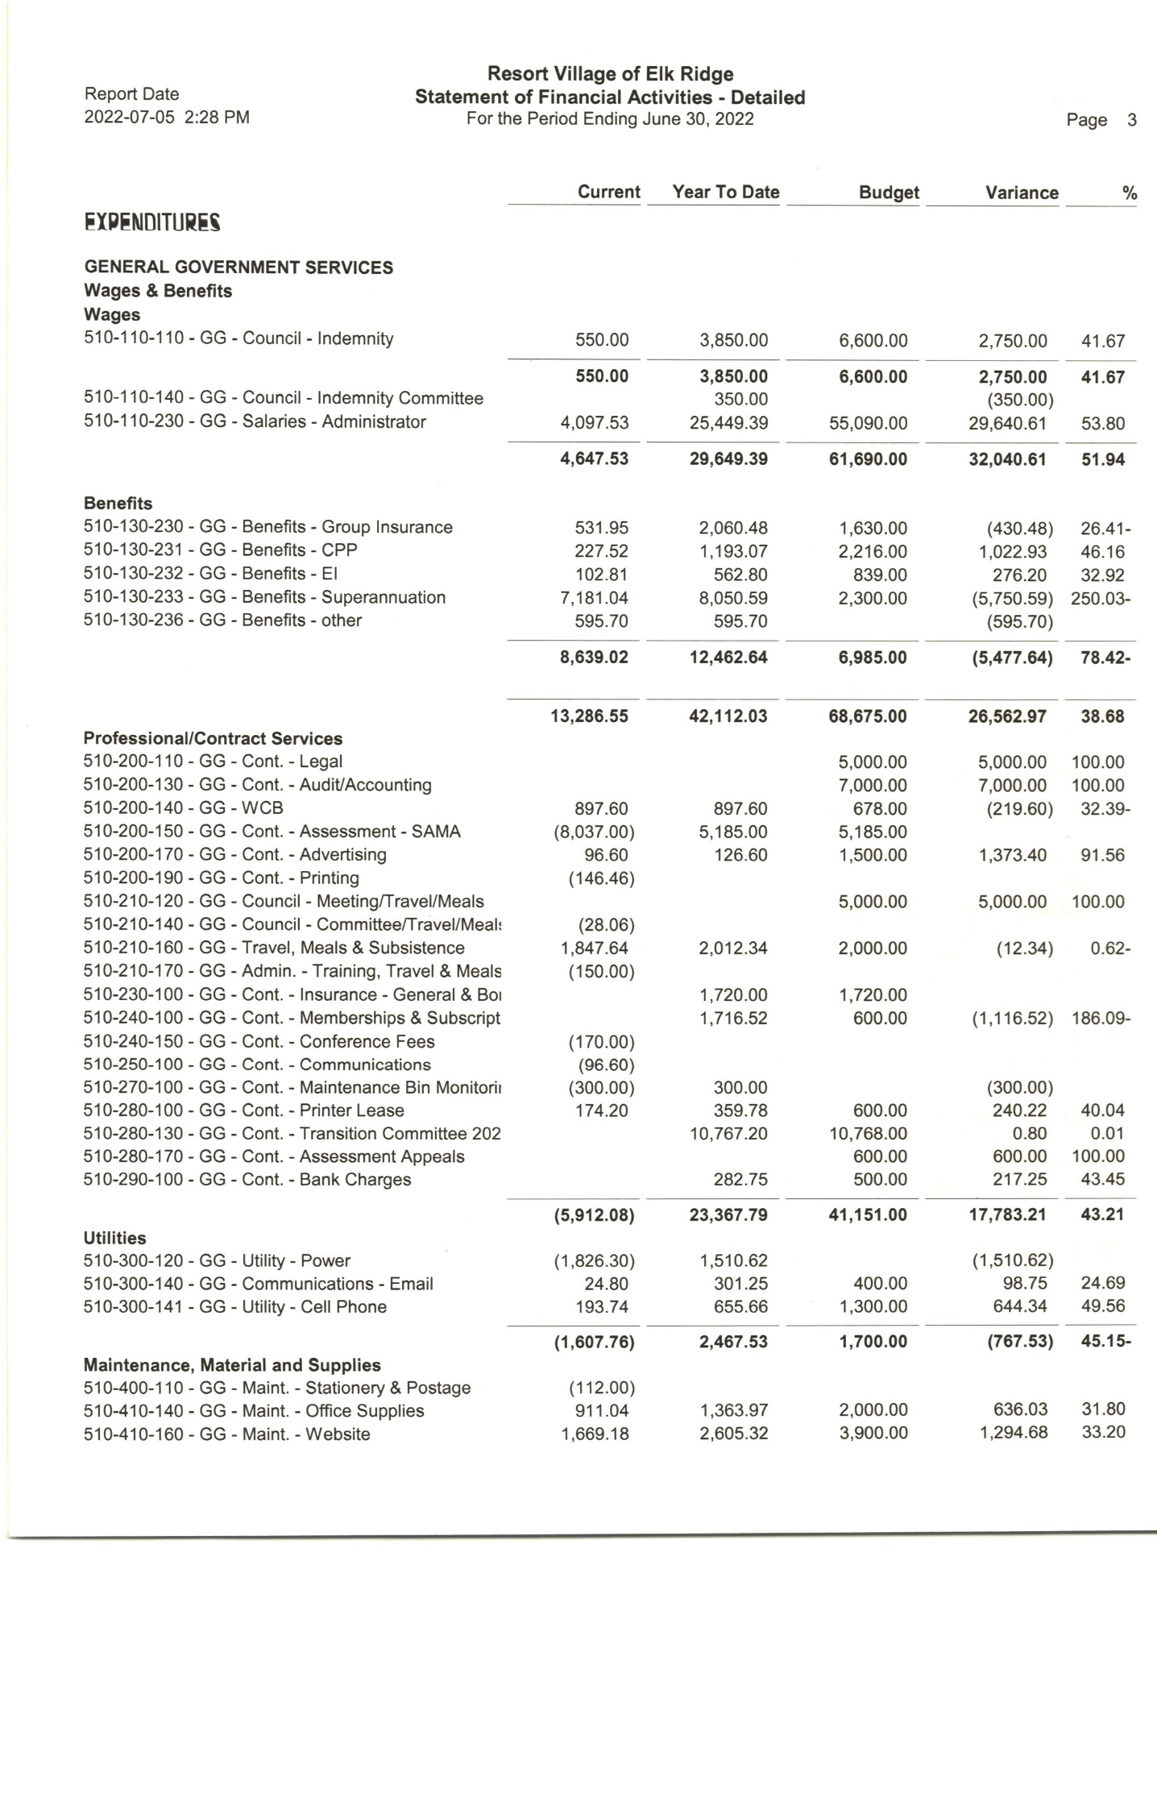

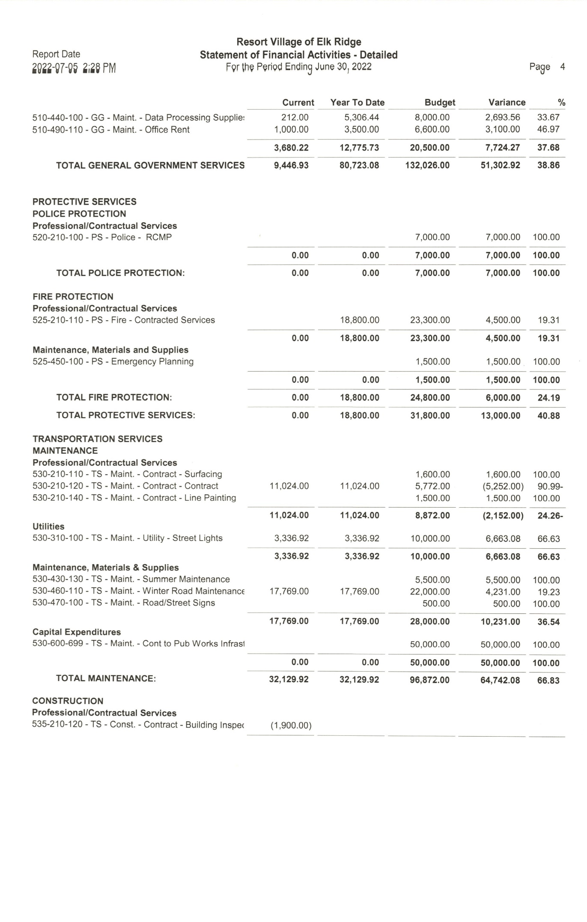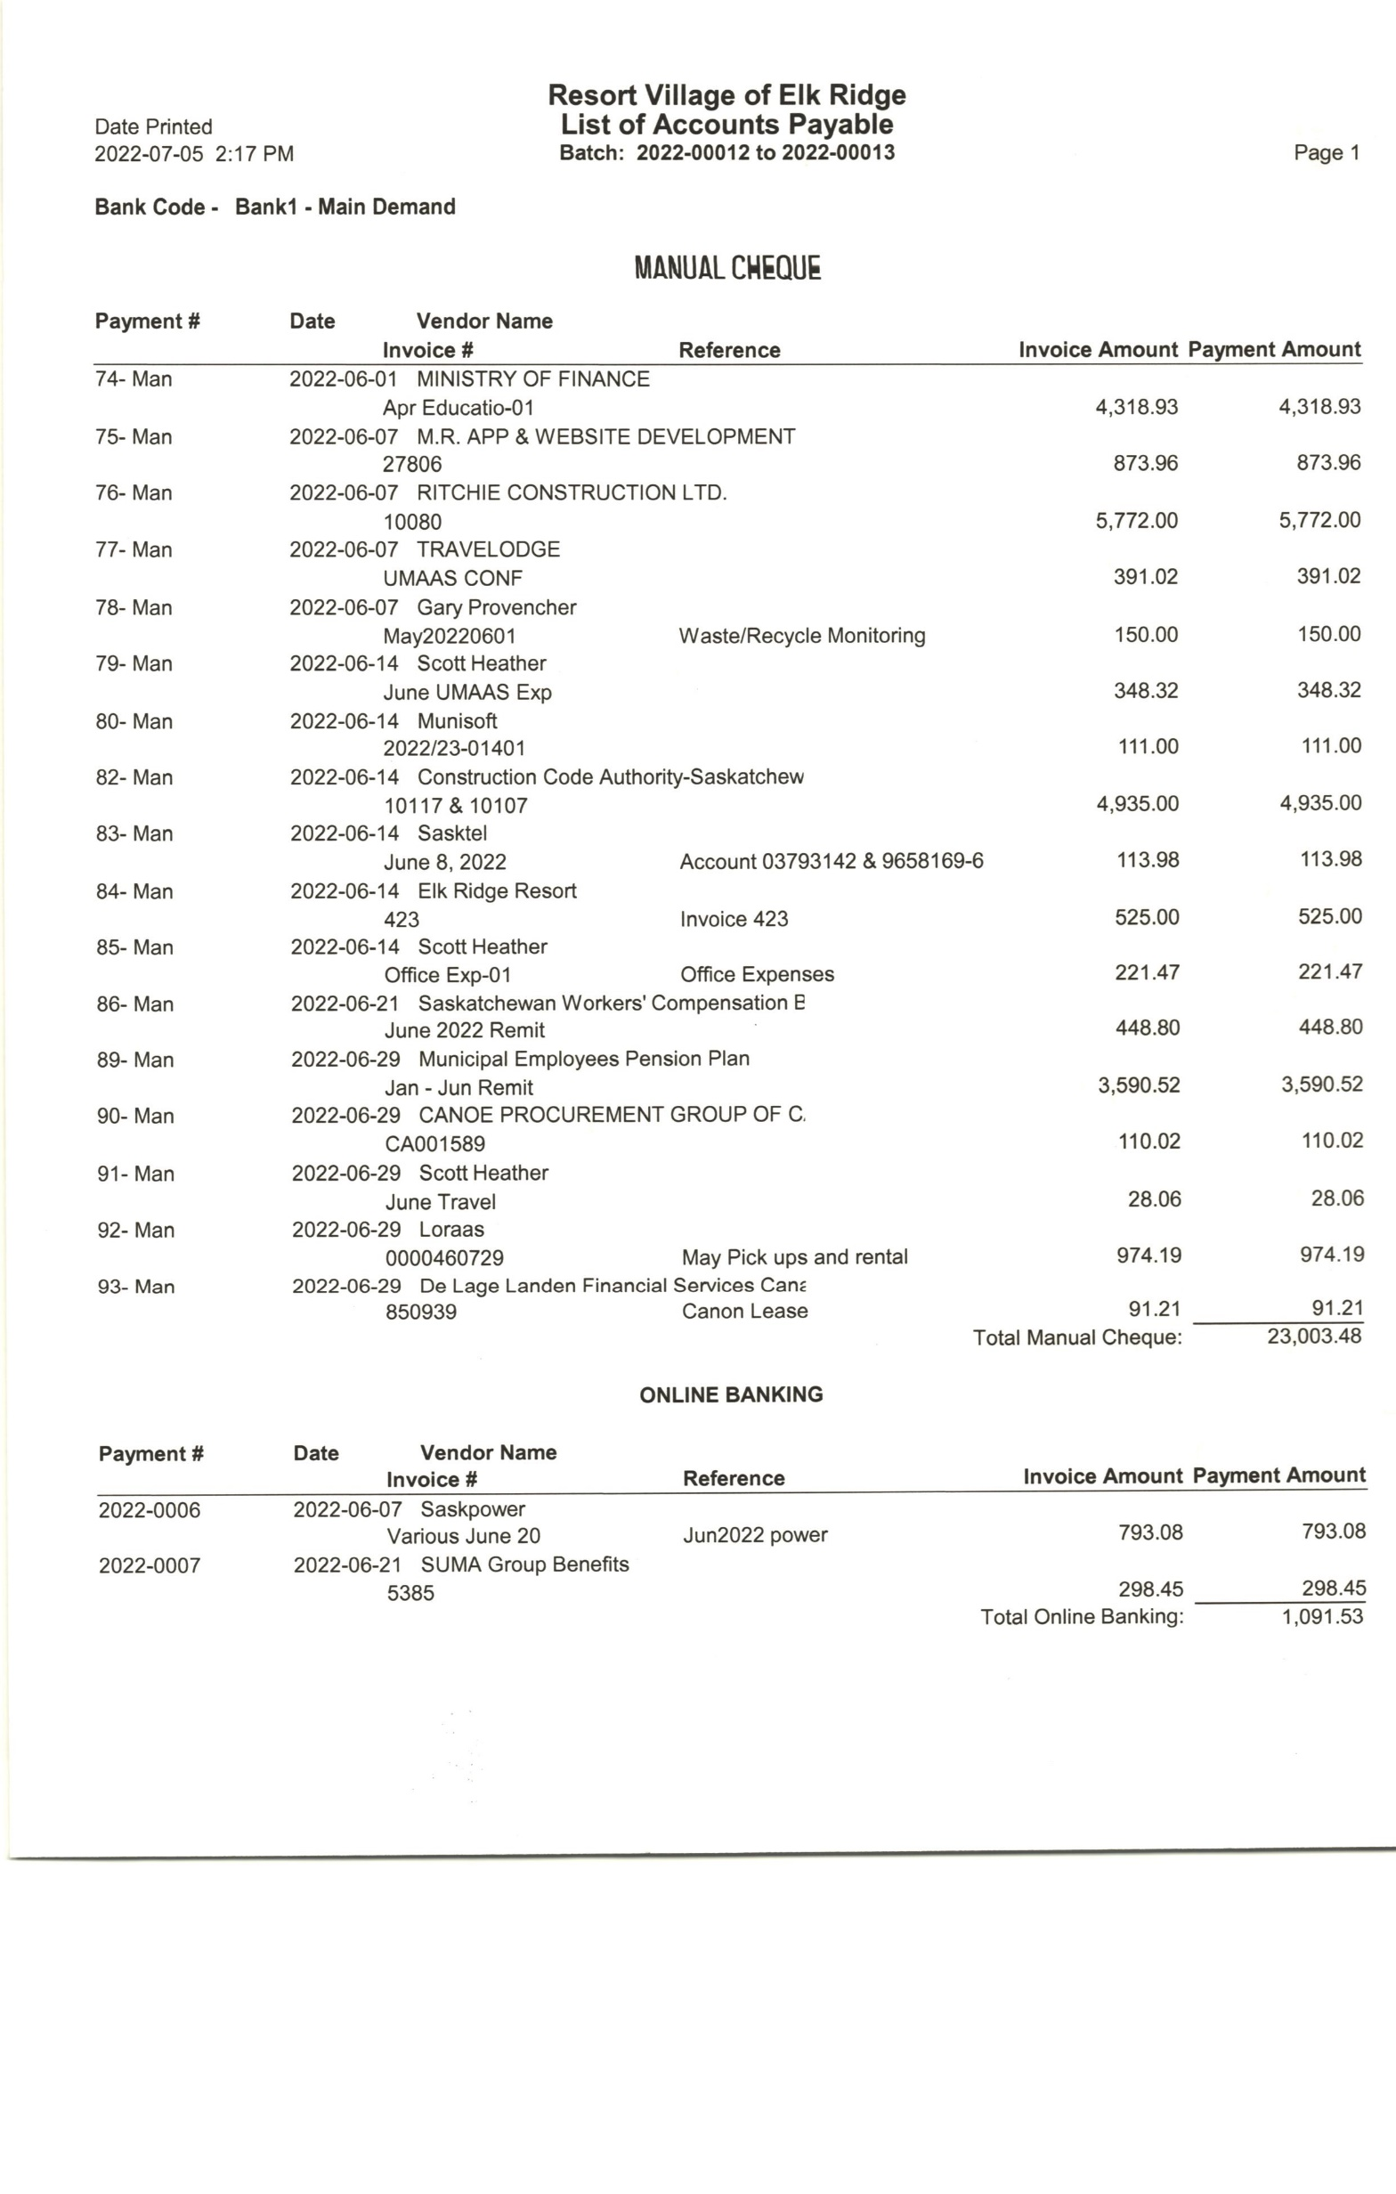

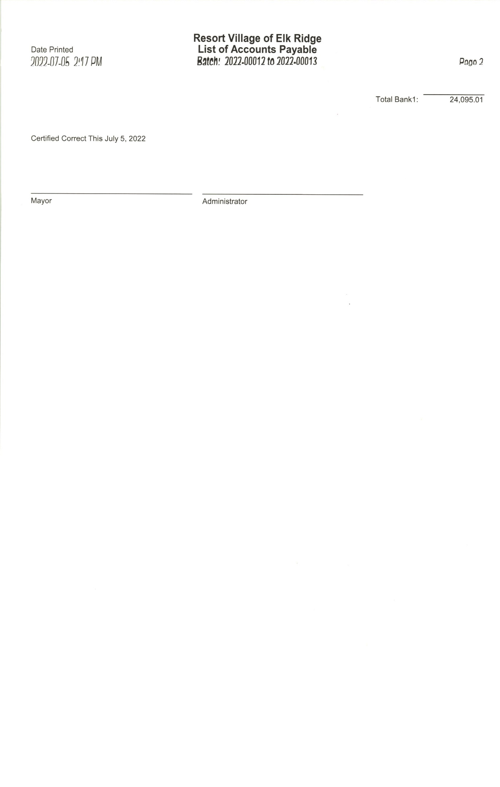

RESORT VILLAGE OF ELK RIDGE  
Bank Reconciliation June 2022

**GL 110-110-120 – General Ledger Account** **$571,787.62**

* Bank Fees -45.75
* Unreceipted etransfers $20,594.96

**Adjusted General Ledge Balance:**  **$592,336.83**

**Bank Account Balance at June 30, 2022 $603,366.51**

* Outstanding Cheques -11,029.68

**Adjusted Bank Balance $592,336.83**