Resort Village of Elk Ridge

Meeting Agenda

June 14th, 2022 at 3:00 p.m. – Regular Meeting -White Tail Room

1. **Call to Order –** The Mayor called the meeting of Council to order.
2. **Delegations:** Fire Chief Chris McShannock, Lakeland District Fire Department
3. **Approval of Agenda:**

MOTION: That the agenda for this meeting be approved as presented.

1. **Public Hearings:** None
2. **Reading of Bylaws:** None
3. **Adoption of Minutes:**

6.1 Page 3– Minutes of the May 10th, 2022 meeting.

MOTION: That the Minutes of the May 10th, 2022 Meeting be approved as presented.

6.2 Page 8– Minutes of the May 24th, 2022 Special Meeting.

MOTION: That the Minutes of the May 24th, 2022 Special Meeting be approved as presented.

6.3 Page 10– Minutes of the June 7th, 2022 Special Meeting.

MOTION: That the Minutes of the June 7th, 2022 Special Meeting be approved as presented.

1. **Business Arising from Minutes:** None
2. **Action/Motion Items:**
   1. Page 12- Governance Training Motion
   2. Page 13 - Budget Report
   3. Page 20 -PARCS Convention
3. **Administration Reports:**

9.1 Page 21 -CAO Report and Updates

1. **Accounts for Payment:**
2. **Financial Statements:**
   1. Page 22– Financial Statement for May, Bank Reconciliation and List of Accounts

MOTION: That Council receive and file the financial statement, bank reconciliation and list of accounts payable for May, 2022.

1. **Council Divisional Reports:** N/A
2. **New Business**: N/A
3. **Incamera:** N/A
4. **Correspondence:**

**15.1** Page 29– EMO Outline provided by Leslie Tuchek

1. **Other Business:**
2. **Adjournment**

Resort Village of Elk Ridge

Meeting Minutes

May 10th, 2022 Regular Meeting of Council

A Regular Meeting of Council of the Resort Village of Elk Ridge was held at the Elk Ridge Golf Resort on May 10th, 2022

Present: Mayor Garry McKay

Councillor Ryan Danberg (*via teams meeting)*

Councillor Trudy Engel

Councillor Ross Hewett

Councillor Margaret Smith-Windsor

Heather Scott, CAO

1. **Call to Order –** With a quorum being present, Mayor Garry McKay called the meeting to order at 3:00 p.m.
2. **Delegations:** Fire Chief Chris McShannock, Lakeland District Fire Department – Unavailable for this meeting; the meeting invite will be extended to the next meeting.
3. **Approval of Agenda:**

**71-2022 SMITH-WINDSOR:** That the agenda for this meeting be approved as amended with three additional items under new business. **CARRIED**

1. **Public Hearings:** None
2. **Reading of Bylaws:** None
3. **Adoption of Minutes:**

6.1 - Minutes of the April 12th, 2022 Council Meeting.

**72**-**2022 HEWETT:** That the Minutes of the April 12th, 2022 Council meeting be approved as amended with name change correction in motion 61-2022.  **CARRIED**

6.2 – Minutes of April 25, 2022 Special Council Meeting.

**73-2022 ENGEL:** That the Minutes of the April 25th, 2022 Special Meeting be approved as presented. **CARRIED**

1. **Business Arising from Minutes:** None
2. **Action/Motion Items:**

8.1 – Bylaw Recommendations from Transition Advisory Committee

**74-2022 SMITH-WINDSOR:** That the minutes of the transition committee dated: February 1st, 2022; February 16th, 2022; March 8th, 2022; April 12th, 2022 and April 25th, 2022 be received and filed. **CARRIED**

**75-2022 ENGEL**: That Bylaws 03, 04, 06, 08, 11, 13, 14. 15, 16, 17, 18, 20, 21 and 22 of 2022 be referred back to Transition Committee for further review.  **CARRIED**

**76-2022 SMITH-WINDSOR:** That Bylaws 05, 07, 09 and 19 be placed on the Agenda for consideration of three readings. **CARRIED**

**77-2022 HEWETT:** That Bylaw 05 of 2022 a Bylaw to establish penalties for contravention of bylaws be introduced and read a first time.  **CARRIED**

**78-2022 ENGEL:** That bylaw 05 of 2022 a Bylaw to establish penalties for contravention of bylaws be now read a second time. **CARRIED**

**79-2022 ENGEL:** That leave be granted for third reading of Bylaw 05 of 2022 a Bylaw to establish penalties contravention of bylaws. **UNANIMOUSLY CARRIED**

**80-2022 SMITH-WINDSOR:** that Bylaw 05 of 2022 a Bylaw to establish penalties for contravention of bylaws be now read a third time and adopted.  **CARRIED**

**81-2022 ENGEL:** That Bylaw 07 of 2022 a Bylaw to establish an assessment appeal fee be introduced and read a first time. **CARRIED**

**82-2022 SMITH-WINDSOR:** That Bylaw 07 of 2022 a Bylaw to establish an assessment appeal fee be now read a second time **CARRIED**

**83-2022 ENGEL:** That Leave be granted for third reading of Bylaw 07 of 2022 a Bylaw to establish assessment appeal fee. **UNANIMOUSLY CARRIED**

**84-2022 DANBERG:** that Bylaw 07 of 2022 a Bylaw to establish an assessment appeal fee be now read a third time and adopted.  **CARRIED**

**85-2022 SMITH-WINDSOR:** That Bylaw 09 of 2022 a bylaw respecting the collection and establishment of fees for municipal services be introduced and read a first time. **CARRIED**

**86-2022 HEWETT:** That Bylaw 09 of 2022 a bylaw respecting the collection and establishment of fees for municipal services be now read a second time  **CARRIED**

**87-2022 DANBERG:** That Leave be granted for third reading of Bylaw 09 of 2022 a Bylaw respecting the collection and establishment of fees for municipal services.  **UNANIMOUSLY CARRIED**

**88-2022 SMITH-WINDSOR:** That Bylaw 09 of 2022 a Bylaw respecting the collection and establishment of fees for municipal services be now read a third time and adopted.

**CARRIED**

**89-2022 ENGEL:** That Bylaw 19 of 2022 a Bylaw for the destruction of documents be introduced and read a first time.  **CARRIED**

**90-2022 HEWETT:** That Bylaw 19 of 2022 a Bylaw for the destruction of documents be now read a second time **CARRIED**

**91-2022 DANBERG:** That Leave be granted for third reading of Bylaw 19 of 2022 a Bylaw for the destruction of documents. **UNANIMOUSLY CARRIED**

**92-2022 SMITH-WINDSOR:** That Bylaw 19 of 2022 a Bylaw for the destruction of documents be now read a third time and adopted.  **CARRIED**

* 1. Assessment Appeal for Improved Properties

**93-2022 HEWETT:** That Council file an assessment appeal for the following properties to account for the improvements on the properties:

1. Unit 81 Plan 100276657 – 81 Estates Drive
2. Unit 45 Plan 100276657 – 45 Estates Drive
3. Unit 31 Plan 100276657 – 31 Estates Drive
4. Unit 32 Plan 100276657 – 32 Estates Drive **CARRIED**
   1. Purchasing Policy/Credit Card

**94-2022 SMITH-WINDSOR:** That Council authorize the administrator to provide public notice and draft a purchasing policy for Council consideration at a future meeting.  **CARRIED**

**95-2022 SMITH-WINDSOR:** That the CAO arrange for acquiring a municipal credit card for operating purchases up to $2500.  **CARRIED**

1. **Administration Reports:** 
   1. CAO Report and Updates.
   2. **HEWETT:**

That Council receive and file the CAO report for April, 2022. **CARRIED**

1. **Accounts for Payment:** N/A
2. **Financial Statements:**

11.1 Financial Statement for April 2022, Bank Reconciliation and List of Accounts.

**97-2022 ENGEL:**

That Council receive and file the financial statement, bank reconciliation and list of accounts payable for April, 2022. **CARRIED**

1. **Council Divisional Reports:** N/A
2. **New Business:**

*Councilor Engel left a 4:53 pm.*

*Councilor Engel returned at 4:54 p.m.*

* 1. EMO Coordinator – Leslie Tuchek verbal report by Councilor Smith-Windsor.

**98-2022 SMITH-WINDSOR:** That Council direct the CAO to work with Leslie Tuchek on a proposal for setting up and maintaining EMO services at the Resort Village of Elk Ridge. **CARRIED**

* 1. Fire Training Exercise
  2. Creation of Recreation Bylaw

1. **Incamera:** N/A
2. **Correspondence:** N/A
3. **Other Business:**

16.1 Councilor Smith-Windsor verbal report RE: NCSWM Annual General Meeting.

1. **Adjournment:**

**99-2022 ENGEL:** That the meeting adjourn 5:24 p.m. **CARRIED**

**_____________________________ ___________________________**

**Mayor CAO**

Resort Village of Elk Ridge

Meeting Agenda

May 24th, 2022 at 3:00 p.m. or later – Special Council Meeting -White Tail Room

A Special Meeting of Council of the Resort Village of Elk Ridge was held at the Elk Ridge Golf Resort on May 24th, 2022.

Present: Mayor Garry McKay

Councillor Ryan Danberg

Councillor Trudy Engel

Councillor Ross Hewett

Councillor Margaret Smith-Windsor

Heather Scott, CAO

1. **Call to Order –** The Mayor called the meeting of Council to order at 3:03 p.m.
2. **Delegations:** N/A
3. **Approval of Agenda**

**100-2022 ENGEL:** That the agenda for this meeting be approved as presented.

**CARRIED**

1. **Public Hearings:** None
2. **Reading of Bylaws:** None
3. **Adoption of Minutes:** None
4. **Business Arising from Minutes:** None
5. **Action/Motion Items:** None
6. **Administration Reports:** None
7. **Accounts for Payment:** None
8. **Financial Statements:** None
9. **Council Divisional Reports:** N/A
10. **New Business**

13.1 – 2022 Budget Review

**101-2022 HEWETT:** That Council convene to incamera session to discuss strategic budget planning at 3:17 p.m. **CARRIED**

**102-2022 SMITH-WINDSOR:** That Council move to open Council meeting at 5:38 p.m. **CARRIED**

1. **Incamera:**
2. **Correspondence:**
3. **Other Business:**
4. **Adjournment**

**103-2022 ENGEL:** The meeting adjourn at 5:38 p.m. **CARRIED**

**_____________________________ ___________________________**

**Mayor CAO**

Resort Village of Elk Ridge

Meeting Agenda

June 7th, 2022 at 1:00 p.m. or later – Special Council Meeting -Discovery Centre

A Special Meeting of Council of the Resort Village of Elk Ridge was held at the Elk Ridge Golf Resort on June 7th, 2022.

Present: Mayor Garry McKay

Councillor Ryan Danberg

Councillor Trudy Engel

Councillor Ross Hewett

Councillor Margaret Smith-Windsor

Heather Scott, CAO

1. **Call to Order –** The Mayor called the meeting of Council to order at 1:00 p.m.
2. **Delegations:** N/A
3. **Approval of Agenda**

**104-2022 SMITH-WINDSOR:** That the draft Budget dated June 7th, 2022 be added as the working copy to today’s meeting. **CARRIED**

**105-2022** **DANBERG:** That the agenda for this meeting be approved as amended. **CARRIED**

1. **Public Hearings:** None
2. **Reading of Bylaws:** None
3. **Adoption of Minutes:** None
4. **Business Arising from Minutes:** None
5. **Action/Motion Items:** None
6. **Administration Reports:** None
7. **Accounts for Payment:** None
8. **Financial Statements:** None
9. **Council Divisional Reports:** N/A
10. **New Business**
    1. – 2022 Budget Review

**106-2022 HEWETT:** That a Public Works Infrastructure Reserve Fund be set up with $50,000 contribution to be allocated from the 2022 budget.  **CARRIED**

**107-2022 SMITH-WINDSOR:** Establish a Recreation and Culture Reserve with contribution of $10,000 in 2022. **CARRIED**

* 1. **ENGEL:** That Council approve the budget amendments listed below:

1. The tax revenue calculation correction on the coverpage;
2. The Building Inspector expenses are moved to Planning and Development GL 560-200-120;
3. The Waste Management Supervision fees be moved from GL 510-270-100 to Enivronment, Health and Wellness GL 540-440-100;
4. New expense item added for Recreation and Culture for $2,000;
5. The expense calculation correction on the coverpage.

**CARRIED**

**109-2022 MCKAY:** That Council set the 2022 mill rate at 2.77, a base tax of $100 per undeveloped property, $200 for developed property, $60 sanitation levy for developed property and $100 fire levy for developed properties. **CARRIED**

1. **Incamera: N/A**
2. **Correspondence:** None
3. **Other Business:** None
4. **Adjournment:**

**110-2022 DANBERG:** The meeting adjourn at 3:04 p.m. **CARRIED**

**_____________________________ ___________________________**

**Mayor CAO**

**DECISION ITEM**

|  |  |
| --- | --- |
| **Subject** | Governance Training |
| **Council Meeting Date Presented:** | June 2, 2022 |
| **Agenda Item:** | 8.1 |
| **Prepared By:** | Heather Scott CAO |

|  |
| --- |
| **BACKGROUND:**   * Council had previously expressed interest in having the Ministry of Government Relations provide governance training for new councils. * The request was parked until all of Council would be able to be present. * This request was followed up on to determine what was required to schedule this training. * Government Relations requires a simple motion of Council for them to schedule the training. |
| **BUDGET & OTHER CONSIDERATIONS:**   * None |
| **RECOMMENDATION:**   * That Council engage governance training from Ministry of Government Relations by passing the proposed motion. |
| **PROPOSED MOTION:**  That Council direct administration to schedule governance training through Saskatchewan Ministry of Government Relations. |
| **Respectfully Submitted by: Heather Scott, CAO** |

**DECISION ITEM**

|  |  |
| --- | --- |
| **Subject** | 2022 Budget Report |
| **Council Meeting Date Presented:** | June 7, 2022 |
| **Agenda Item:** | 8.2 |
| **Prepared By:** | Heather Scott CAO |

|  |  |  |  |  |  |  |  |  |  |  |  |  |  |  |  |  |  |  |  |  |  |  |  |  |  |  |  |  |  |  |  |  |  |  |  |  |  |  |  |  |  |  |  |  |  |  |  |  |  |  |  |  |  |  |  |  |  |  |  |  |  |  |  |  |  |  |  |  |  |  |  |  |  |  |  |  |  |  |  |  |
| --- | --- | --- | --- | --- | --- | --- | --- | --- | --- | --- | --- | --- | --- | --- | --- | --- | --- | --- | --- | --- | --- | --- | --- | --- | --- | --- | --- | --- | --- | --- | --- | --- | --- | --- | --- | --- | --- | --- | --- | --- | --- | --- | --- | --- | --- | --- | --- | --- | --- | --- | --- | --- | --- | --- | --- | --- | --- | --- | --- | --- | --- | --- | --- | --- | --- | --- | --- | --- | --- | --- | --- | --- | --- | --- | --- | --- | --- | --- | --- | --- |
| **BACKGROUND:**   * The Council of the Resort Village of Elk Ridge met and determined the 2022 Tax Levy. * The taxes are comprised of a mill rate of 2.77 for all properties, $100 base tax with an additional $100 for improved properties, a special sanitation levy of $60 for developed properties and a special fire levy of $100 for all developed properties.   **Taxes:**   |  |  |  |  |  |  |  |  | | --- | --- | --- | --- | --- | --- | --- | --- | | Property Class | |  |  | Assessment | Mill Rate Factor | Base Tax and Special Levy | Total Municipal  Tax Levy | |  | |  |  |  |  |  |  | | Residential | |  |  | 658,560 | 2.77 |  | $1,824 | | Base Tax Land | |  |  |  |  | 100 | $24,900 | | Base Tax Improvement | | |  |  |  | 100 | $18,800 | | Multi-Unit Residential | |  |  | 70,816,400 | 2.77 |  | $196,161 | | Sanitation Levy | |  |  |  |  | 60 | $11,280 | | Fire |  |  |  |  |  | 100 | $18,800 | | Commercial and Industrial | | |  | 6,213,500 | 2.77 | 100 | $17,211 | |  | | |  |  |  |  |  |   **Budget Overview:**  Total 2022 Revenue: $341,203  Total 2022 Expenses: $253,498  Infrastructure Reserve Fund Transfer: $50,000  Culture and Recreation Reserve Fund Transfer: $10,000  Budgeted Surplus $27,205  **Bylaws:**  Bylaw 10 – 2022 Fire Service Levy Bylaw  Bylaw 24 – 2022 Base Tax Bylaw  Bylaw 25 – 2022 Mill Rate Bylaw  Bylaw 26 – 2022 Sanitation Levy Bylaw  **Other Items of Note:**   * The Municipal Revenue Sharing allocation for Elk Ridge this year is 30,101. * This budget also contains $10,768 of 2021 invoices of transition expenses that were required to be incorporated into the 2022 budget. * There were also several one time costs for set up that were included in the 2022 budget including CAFT set up, SAMA set up and over $5000 for set up of Munisoft computer programs. |
| **BUDGET & OTHER CONSIDERATIONS:**  To set the 2022 Budget for Revenue: $341,203 and Expenses: $253,498 |
| **RECOMMENDATION:**   * That Council approve the 2022 budget and ratify the taxation bylaws. |
| **PROPOSED MOTION:**   * That Council approve the 2022 budget amended and consider three readings of Bylaw 10-2022 – The Fire Service Levy Bylaw, 24-2022 as amended – the Base Tax Bylaw, 25-2022 – The Mill Rate Bylaw and Bylaw 26-2022 the Sanitation Levy Bylaw. |
| **Respectfully Submitted by: Heather Scott, CAO** |

**RESORT VILLAGE OF ELK RIDGE**

**BYLAW NO. 10-2022**

**A BYLAW TO AUTHORIZE A SPECIAL TAX FOR FIRE PROTECTION SERVICES.**

The Council of the Resort Village of Elk Ridge in the Province of Saskatchewan enacts as follows:

1. A special tax shall be levied against every improved property that has a taxable assessment within the boundaries of the resort village for fire protection services to be completed within the current year.
2. The special tax rate to be levied against every improved property is $100.00.
3. The taxes that are levied will be added to the tax roll as a special assessment against the property, when they become due and payable, and are recoverable in the same manner as other taxes.
4. This bylaw shall come into effect on the day of its final passing.

__________________________________

Mayor

{Seal}

__________________________________

Administrator

Read a third time and adopted

this ____ day of ___________

**RESORT VILLAGE OF ELK RIDGE**

**BYLAW NO. 24-2022**

**A BYLAW TO PROVIDE FOR A BASE TAX**

The Council of the Resort Village of Elk Ridge enacts as follows:

1. This bylaw shall be known as the “Base Tax Bylaw”.
2. A base tax shall apply to the types and classifications of property included in the table below for all property within the boundaries of the Resort Village of Elk Ridge:

|  |  |  |  |
| --- | --- | --- | --- |
| Property  Class | Type of Property | | |
| Land | Improvements | Land &  Improvements |
| Agriculture | - | - | - |
| Residential | 100 | 100 | 200 |
| Commercial  & Industrial | 100 | 100 | 200 |

1. Where a property is classified within more than one property classification by the Saskatchewan Assessment Management Agency, the base tax calculation shall be considered independently and applied to each classification.
2. This Bylaw shall come into effect on the day of its final passing.

__________________________________

Mayor

{Seal}

__________________________________

Administrator

Read a third time and adopted

this ____ day of ___________

**RESORT VILLAGE OF ELK RIDGE**

**BYLAW NO. 25 - 2022**

**A BYLAW TO ESTABLISH MILL RATE FACTORS FOR THE YEAR 2022**

The Council of the Resort Village of Elk Ridge enacts as follows:

1. This bylaw shall be known as the “Mill Rate Factor Bylaw”.
2. The following mill rate factor(s) shall be applied to the uniform mill rate levied against all taxable property for municipal purposes:`

|  |  |
| --- | --- |
| **Property Class** | **Factor** |
| Agriculture | 2.77 |
| Residential | 2.77 |
| Commercial & Industrial | 2.77 |

1. This Bylaw shall come into effect on the day of its final passing.

__________________________________

Mayor

{Seal}

__________________________________

Administrator

Read a third time and adopted

this ____ day of ___________

**RESORT VILLAGE OF ELK RIDGE**

**BYLAW NO. 26 - 2022**

**A BYLAW TO AUTHORIZE A SPECIAL TAX**

**FOR REFUSE COLLECTION SERVICES**

The Council of the Resort Village of Elk Ridge in the Province of Saskatchewan enacts as follows:

1. A special tax shall be levied against every property used for residential or commercial purposes that has a taxable assessment within the boundaries of the Resort Village of Elk Ridge for refuse collection services.
2. The estimated cost of the refuse collection services for the current year is $12,000.
3. The special tax rate to be levied in 2022 against every improved taxable property used for residential or commercial purposes shall be as listed below and applicable to the respective areas of the municipality.

* 1. All developed properties that will have the benefit of a dumpster only on a year round basis shall be levied $60.00 as a Special levy.

1. The special taxes referred to in Section 3 shall be levied as one special tax against the property for 2022.
2. Any person who considers that an error or omission was made in the application or calculation of the special tax on his or her property may notify the municipality in writing by September 1 in any given year requesting the Council to review the application or calculation of the tax rate regarding the property in question.
3. The Administrator will notify the persons, who have requested a review, of the time and date the Council will meet to hear and review the requests.
4. The taxes that are levied will be added to the tax roll as a special assessment against the property, when they become due and payable, and are recoverable in the same manner as other taxes.
5. This Bylaw shall come into effect on the day of its final passing.

__________________________________

Mayor

{Seal}

__________________________________

Administrator

Read a third time and adopted

this ____ day of ___________

**DECISION ITEM**

|  |  |
| --- | --- |
| **Subject** | PARCS 2022 Convention |
| **Council Meeting Date Presented:** | June 2, 2022 |
| **Agenda Item:** | 8.3 |
| **Prepared By:** | Heather Scott CAO |

|  |
| --- |
| **BACKGROUND:**   * PARCS stands for the Provincial Association of Recreation Communities of Saskatchewan. * PARCS will be returning to a face-to-face convention this year. * This year’s convention will be held in Saskatoon on October 14 – 15, 2022. October 14 will be a full day and the 15th will be a half day. * This year the convention will focus on the two themes below:   An **environmental theme** - A panel of guest experts will discuss what needs to be done in order to protect the diminishing quality of our lake water due to wetland drainage.  This session is chaired by and sponsored by Ducks Unlimited.  A **sharing of everyday management** - A number of our cottage communities will share their tales about managing their community's challenges. This Members' Fair will include stories from resort villages, from organized hamlets, and from RMs. |
| **BUDGET & OTHER CONSIDERATIONS:**   * Registration costs for Member Municipality costs are $225 per person + travel and meals. * PARCS negotiated a convention rate of $143.20 + tax for hotel rooms at the host hotel. * Additional mileage and meal costs at .61 per km + meals not provided at convention. |
| **RECOMMENDATION:**   * This may not be a convention that is required to be attended annually, but is still a very informative convention directed to resort communities. * It is recommended that some interested members of Council and the CAO attend this year. |
| **PROPOSED MOTION:**  That Council approve for the attendance of interested council members and the CAO at the 2022 PARCS Convention in Saskatoon on October 14 & 15, 2022. |
| **Respectfully Submitted by: Heather Scott, CAO** |

Administrator Report – June, 2022

* The assessment roll closed on May 25, 2022 and the Resort Village of Elk Ridge had no other appeals other than the three at the municipality initiated. SAMA reinspected the three properties on May 31, 2022 and is drafting an agreement to amend the current assessments with the owners.
* The streets have all now been swept and line painting has been contracted through the Ministry of Highways. They expect it will be done in the first part of June.
* Leslie Tuchek has been contacted to initiate EMO planning. She has a few other people that she is able to utilized to assist the Resort Village of Elk Ridge with the training and draft of an EMO plan. Leslie will provide a template breaking out the components required for developing an EMO plan and assist with walking us through to development. She has provided a budget estimate for work to be done this year.
* On May 24, 2022, the CAO and Mayor attended the North Central Lakeland District Planning Commission Meeting.
* The CAO attended the UMAAS 2022 convention in Saskatoon from June 7-10, 2022. This convention has not taken place in person for two years. This convention packed a lot of information to catch up on. George Cuff was a guest speaker. He is a wealth of knowledge in municipal governance and provided many resources for administrators in attendance. There were also many exhibitors and presentations by Construction Code Authority on updates with respect to Building Codes, MEPP, Kinetic GPO, University of Regina, SUMA and SUMAssure, Southeast College, The Minster of Government Relations, the Board of Examiners and Government Relations Advisory Services who provided Legislative Updates and Amendments. TSASK was also in attendance to explain revised plumbing permitting.

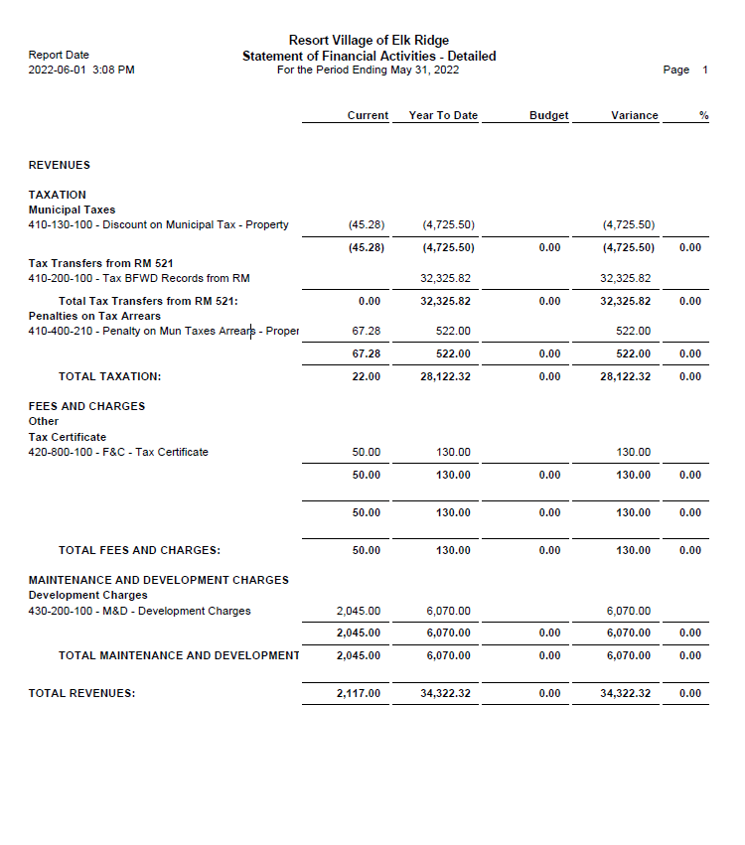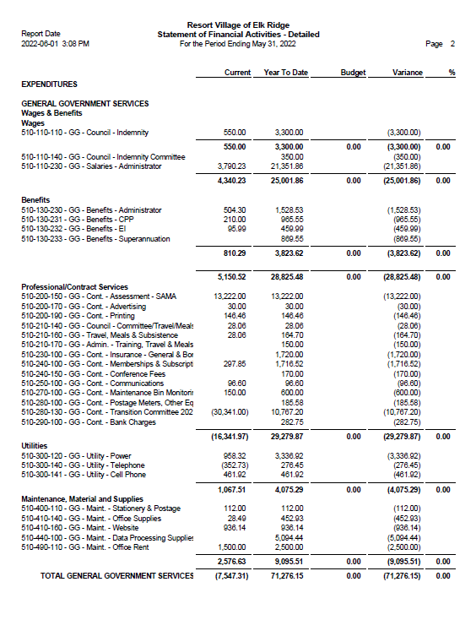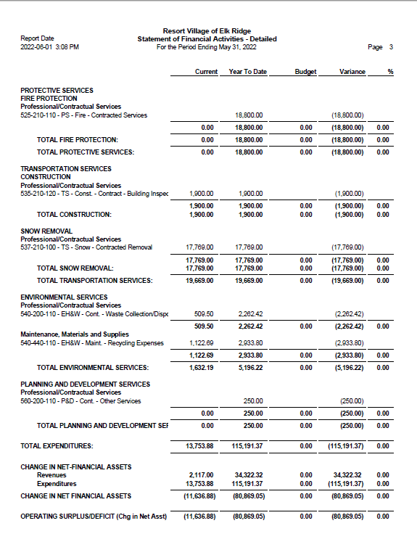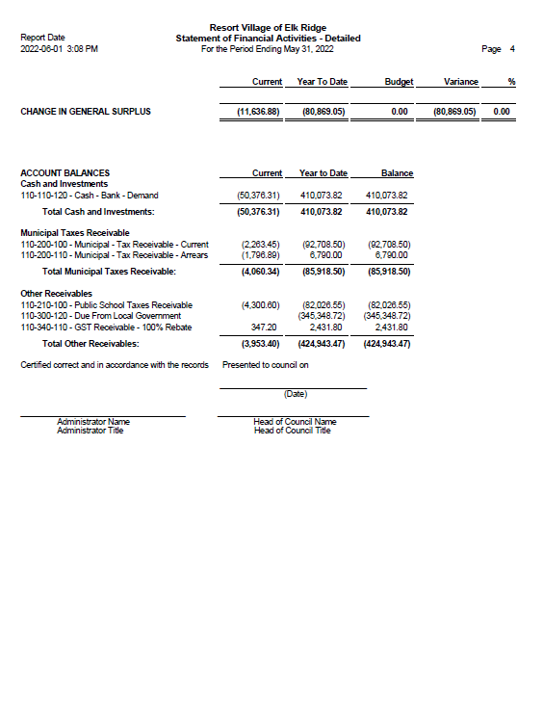

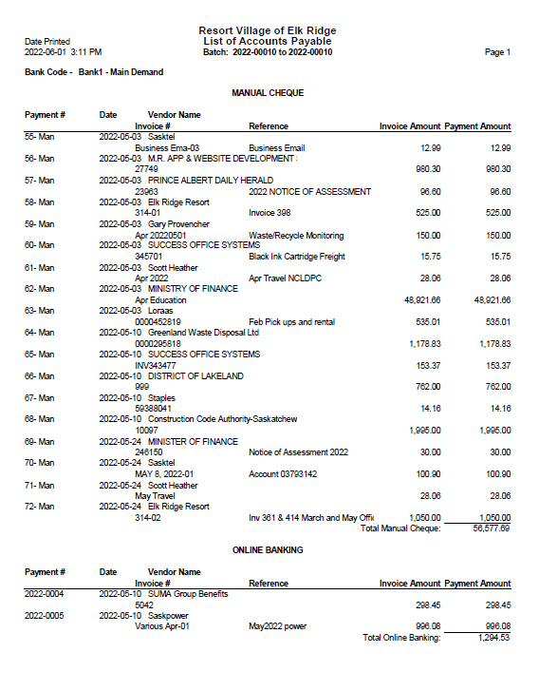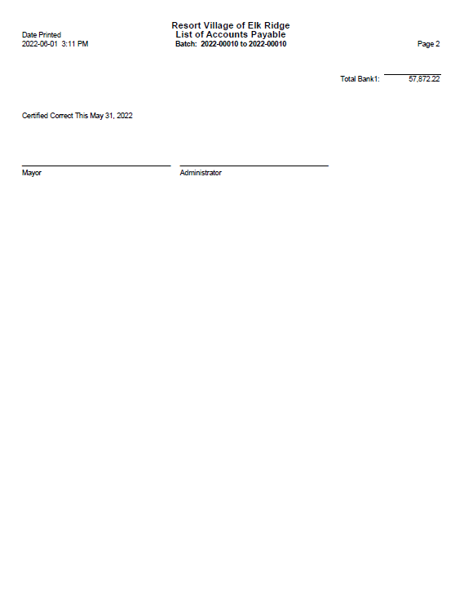

RESORT VILLAGE OF ELK RIDGE  
Bank Reconciliation May 2022

**GL 110-110-120 – General Ledger Account** **$410,073.82**

* Bank Fees -40.25

**Adjusted General Ledge Balance:**  **$410,033.57**

**Bank Account Balance at May 31, 2022 $412,832.75**

* Outstanding Cheques -2,799.18

**Adjusted Bank Balance $410,033.57**

Resort Village of Elk Ridge Emergency Response Plan Components and considerations for your Emergency Management Organization.

Created by Leslie Tuchek June 3rd, 2022

**Emergency Management Planning involves 4 distinct components:**

* mitigation/prevention-awareness and reduction of risk
* preparedness-comprehensive response plans, forward thinking, collaboration, emergency service contracts & mutual aid agreements, community emergency awareness
* response-activation of response plans and activation emergency services
* recovery-clean up & rebuilding after an event, disposal of debris and hazardous goods, disaster assistance programs

The **Saskatchewan Emergency Act** lays out the roles and responsibilities of a local authority. Sections of particular interest in planning are:

Local emergency plans Section 9

Duty of local authorities Section 10,

Mutual aid areas Section 11

Powers of local authority Section 21

**Things to consider during the creation of an emergency response plan**

* Written contracts with emergency services and mutual aid agreements are needed
* Join SEPA (Saskatchewan Emergency Planners Association)-Send attendees to their annual meeting-SEPA.ca
* Store your response plan and all related emergency response data to a server that can be accessed remotely by your EOC team. Google or Microsoft Teams. Have paper backup of all forms and your plan.
* Video conferencing tool for remote emergency activation capability
* Establish an Emergency Operations Centre (EOC) and (EOC) team
* Communication & notification method and alerting systems for, residents and visitors and emergency services
* A Hazard, Risk & vulnerability assessment is required to create an all-hazards plan
  + differentiate between everyday emergencies and disaster planning.
  + Risks-wildfire, windstorm/tornado, lightning, extended power outages, active shooter, communication failure (solar flares), pandemic etc.
  + Vulnerabilities: visitors, daycare, schools, water treatment, access to & from the community, emergency service response time
  + Hazards: communication towers, hazardous chemicals, propane storage, recreation vehicles, communication internet failure,
  + Who the plan will serve? individuals/ full time/seasonal/short term visitors, businesses. Overlap of emergency response plans between businesses (Convention Centre, golfing, ziplining) and community.
  + Notification/alerting system for community
* When appointing an emergency measures coordinator, keep in mind that municipal administration must continue even during an emergency event. It may be difficult for the coordinator to perform multiple roles if they are part of the municipal team. Or a replacement for their municipal duties could step in. Typically, Council is not part of the Emergency Operations Centre Team, nor should they be in the EOC. Their involvement is through the EOC Director.
* Subscribe to online environmental warning services such as:
* ECCC Warning Preparedness Meteorologists

Contact Terri Lang Environment and Climate Change Canada

Tel: 306 975-4036

Email: [Terri.Lang@canada.ca](mailto:Terri.Lang@canada.ca)

This group emails extreme weather forecasts that are usually in advance or use different modelling than the typical weather apps. They hold conference calls when there are indications of upcoming significant weather events

* PASPC-Prairies Thunderstorm Outlook

Thunderstorm outlook for the prairies sent via email daily.

Contact: Natalie Hasell

Email: [natalie.hasell@canada.ca](mailto:natalie.hasell@canada.ca)

* Wildfire Status in Saskatchewan: <https://www.saskpublicsafety.ca/emergencies-and-response/wildfire-status>

**ERP components needed:**

Activation flow chart

Reporting and Alerting Authorities

* 911
* SPSA
* RCMP
* Residents, seasonal owners, visitors (notification/alerting system? Disaster alarm?
* Emergency numbers and Contact information

Communication

* How will you communicate with emergency response services? and the public? Contingency for outages
* How will you communicate with the public on location and away? Contingency for outages (Facebook, email, phone)
* Notification/alerting system for residents & visitors

Maps

* Topographical
* Subdivisions, streets, indicate hazards

Evacuation

* Evacuate or shelter in place
* Evacuation routes with maps & possible signage
* Notification stages
* Registration
* Community access (emergency vehicles, getting people out simultaneously with one road entrance)
* Resources to assist evacuation-typically RCMP, fire department etc but must be identified

Media

* Dealing with and using the media as a notification partner
* Assigned/trained spokesperson(s)

Contracts & Mutual Aid agreements

Emergency Operations Centre & EOC Team

* Have an established EOC location
* Training for EOC members

Resources & Resources contact list:

* Equipment and trained operators on site
* Equipment, operators available offsite-with written agreements (disposal companies)
* Technical resources on site and offsite (waste management, computer)
* Stakeholders and partners SPSA, SaskEnviroment Wildfire Division, PANP Wildfire

Policies, Procedures and bylaws

* Declaring & terminating a state of emergency (see Saskatchewan Emergency Act)
* Declaring fire bans
* Invoking and removing evacuation orders

Policies for updating and maintenance of Emergency Management Plan

* ERP
* EOC supplies and location
* Training EOC
* Review of hazards and vulnerabilities.
* Exercise the plan 1x per year, involve emergency services
* Training new staff