Resort Village of Elk Ridge

Meeting Agenda

September 13th, 2022 at 3:00 p.m. – Regular Meeting – Elk Ridge Golf Resort

1. **Call to Order –** The Mayor called the meeting of Council to order.
2. **Delegations:**
3. **Approval of Agenda:**

MOTION: That the agenda for this meeting be approved as presented.

1. **Public Hearings:** None
2. **Reading of Bylaws:**

5.2 **-** Bylaw 27 of 2022 - Open Air Fire Restriction Bylaw – Tabled from August 9th, 2022 meeting pending further review.

5**.**3 Bylaw 15 of 2022 The Council Procedure Bylaw.

1. **Adoption of Minutes:**

6.1 Page 2 – Minutes of the August 9th, 2022 meeting.

MOTION: That the Minutes of the August 9th, 2022 Meeting be approved as presented.

1. **Business Arising from Minutes:** None
2. **Action/Motion Items:**
   1. Page 8-Community Services Committee Terms of Reference
3. **Administration Reports:**

9.1 Page 9-CAO Report and Updates

1. **Accounts for Payment:**
2. **Financial Statements:**
   1. Page 11 – Financial Statement for August, Bank Reconciliation and List of Accounts

MOTION: That Council receive and file the financial statement, bank reconciliation and list of accounts payable for August, 2022.

1. **Council Divisional Reports:** N/A
2. **New Business**:
3. **Incamera:**
4. **Correspondence:**

**15.1** Page 18 -Charging Station Grant – Ecoquest Canada

1. **Other Business:**
2. **Adjournment**

Resort Village of Elk Ridge

Meeting Minutes

August 9th, 2022 Regular Meeting of Council

A Regular Meeting of Council of the Resort Village of Elk Ridge was held at the Elk Ridge Golf Resort on August 9th, 2022.

Present: Mayor Garry McKay

Councillor Ryan Danberg

Councillor Trudy Engel

Councillor Ross Hewett

Councillor Margaret Smith-Windsor

Heather Scott, CAO

1. **Call to Order –** With a quorum being present, Mayor Garry McKay called the meeting to order at 3:00 p.m.
2. **Delegations:**

*Councilor Danberg having declared a conflict of interest, left at 3:04 p.m.*

**2.1** Darcy Simoneau – Route2SK RV Park request for abatement of fees.

*Councilor Danberg returned at 3:16 p.m.*

**2.2** Jim Walters – Crosby Hannah & Associates

1. **Approval of Agenda:**

**212-2022 SMITH-WINDSOR:** That the agenda for this meeting be approved as amended.

1. **CARRIED**
2. **Public Hearings:** None
3. **Reading of Bylaws:**

**5.1 –** Bylaw 02 of 2022 A Bylaw Respecting Buildings

**213-2022 ENGEL:** That Bylaw 02 of 2022 a Bylaw Respecting Buildings be introduced and read a first time. **CARRIED**

**214-2022 DANBERG:** That Bylaw 02 of 2022 a Bylaw Respecting Buildings be now read a second time. **CARRIED**

**215 – 2022 HEWETT:** That leave be granted for the third reading of Bylaw 02 of 2022 a Bylaw Respecting Buildings. **UNANIMOUSLY CARRIED**

**216-2022 SMITH-WINDSOR:** That Bylaw 02 of 2022 a Bylaw Respecting Buildings be read a third time and adopted. **CARRIED**

**5.2 –** Bylaw 27 of 2022 a Bylaw Respecting Open-Air Fire Restriction.

**217-2022 ENGEL:** That Bylaw 27 of 2022 a Bylaw Respecting Open-Air Fire Restriction be tabled pending further review. **CARRIED**

**5.3 –** Bylaw 12 of 2022 a Bylaw to Regulate the Operation of Vehicles and Use of Highways.

**218-2022 ENGEL:** That Bylaw 12 of 2022 a Bylaw to Regulate the Operation of Vehicles and Use of Highways be introduced and read a first time. **CARRIED**

**219-2022 DANBERG:** That Bylaw 12 of 2022 a Bylaw to Regulate the Operation of Vehicles and Use of Highways be read a second time. **CARRIED**

**220-2022 HEWETT:** That leave be granted for the third reading of Bylaw 12 of 2022 a Bylaw to Regulate the Operation of Vehicles and Use of Highways.

**UNANIMOUSLY CARRIED**

**221-2022 SMITH-WINDSOR:** That Bylaw 12 of 2022 a Bylaw to Regulate the Operation of Vehicles and Use of Highways be now read a third time and adopted.

**CARRIED**

1. **Adoption of Minutes:**

**6.1** - Minutes of the July 12th, 2022 Council Meeting.

**222–2022 ENGEL:** That the Minutes of the July 12th, 2022 Council Meeting be approved as presented. **CARRIED**

**6.2 –** Minutes of the July 29th, 2022 Special Meeting.

**223-2022 HEWETT:** That the Minutes of the Jul 29th, 2022 Special Meeting be approved as presented.  **CARRIED**

1. **Business Arising from Minutes:** None
2. **Action/Motion Items:**

**8.1** – Council Committee Appointments: Executive Committee, Pubic Works Committee and Finance Committee.

**224-2022 SMITH-WINDSOR:** That Council approves the terms of reference and establishment of an Executive Committee of Council. **CARRIED**

**225-2022 DANBERG:** That Council approves the terms of reference and establishment of a Public Works Committee and appoint Councilors Smith-Windsor and Hewett to the committee. **CARRIED**

**226-2022 SMITH-WINDSOR:**  That Council approves the terms of reference and establishment of a Finance Committee and appoint Mayor McKay and Councilor Engel to the committee.  **CARRIED**

**227-2022 ENGEL:** That Council approves the establishment of a Community Services Committee and appoint Councilors Danberg and Smith-Windsor to the committee.  
 **CARRIED**

* 1. **-** Municipal Investment.

**228-2022 HEWETT:** That Council approve the investment of $200,000 in a 2 year GIC with the Affinity Credit Union. **CARRIED**

*Councilor Danberg having declared a conflict of interest left the meeting at 5:23 p.m.*

8.3 – Routes2SK – RV Park Abatement Request

**229-2022 HEWETT:** In recognition of the late season opening of the new RV sites, Council approves the reduced the 2022 fees for the new RV sites by 50%. **CARRIED**

**230-2022 SMITH-WINDSOR:**  That Council direct a cheque be sent to the Lakeland District Fire Co-op in the amount of $2,100 representing the cabin trailer fees and the occupied sites in the new RV Park. **CARRIED**

*Councilor Danberg returned at 5:37 p.m.*

1. **Administration Reports:** 
   1. CAO Report and Updates.

**231-2022 ENGEL:** That Council receive and file the CAO report for August, 2022. **CARRIED**

1. **Accounts for Payment:** N/A
2. **Financial Statements:**

11.1 Financial Statement for July 2022, Bank Reconciliation and List of Accounts.

**232-2022 DANBERG:**

That Council receive and file the financial statement, bank reconciliation and list of accounts payable for July, 2022 with an updated financial statement be forwarded to Council. **CARRIED**

1. **Council Divisional Reports:** N/A
2. **New Business:** None
3. **Incamera:**

**233-2022 HEWETT:**

That Council move to incamera meeting to discuss a personnel matter at 6:20 p.m.

**CARRIED**

*Heather Scott, CAO left the meeting at 6:20 p.m.*

**234-2022 SMITH-WINDSOR:**

That Council reconvene to regular Council meeting at 6:29 p.m. **CARRIED**

1. **Correspondence:**

**15.1 –** Email dated July 25, 2022 from Wendy Gowda

1. **Other Business:** None
2. **Adjournment:**

**235-2022 DANBERG:** That the meeting adjourn 6:30 p.m. **CARRIED**

**_____________________________ ___________________________**

**Mayor CAO**

 RESORT VILLAGE OF ELK RIDGE

TERMS OF REFERENCE

COMMUNITY SERVICES COMMITEE

PURPOSE:

To provide support and direction to the CAO on matters dealing with the planning and implementation of community services in the Resort Village of Elk Ridge.

GOVERNANCE:

The Committee is responsible to Council.

MEMBERS:

1. Margaret Smith-Windsor

2. Ryan Danberg

3. CAO, Advisor

FUNCTION:

To provide support and direction to the CAO on matters dealing with community services in the Resort Village of Elk Ridge.

MEETINGS:

As required

Administrator Report – September 2022

New Updates:

* There have been 8 building permits issued so far this year. 7 for principal dwellings and one for a detached garage. There are also 2 other pending permits at various stages.
* A request has been submitted for quote for a community Highway sign to the Ministry of Highways.
* Quotes were received for fire ban and speed signs. As members of SUMA, we received discounted pricing. These signs were sent to the Public Works Committee for feedback before ordering.
* I have successfully signed up for notifications of outages by SaskPower in the area to able to notify the residents of any upcoming outages.
* I have worked with Wendy Gowda to adjust the recording of the tax account balances from the RM to remove them from being recorded as current revenues. Wendy recommended that we should record them under an asset account. GL entries were therefore done and the amounts were recorded in asset account GL 120-110-100.
* In lieu of the recent alerts that have gone out in Saskatchewan, I have reached out to the Sask Public Safety Agency to determine any upcoming training opportunities to authorize Sask Alert notifications in the Elk Ridge Community.
* The second intake for the Targeted Sector Funding is being applied for by the North Central District Planning Commission a planning group with the Resort Village of Elk Ridge is a member. Some of the items discussed at the August 23, 2022 Commission meeting were air bnb’s and regulation of them, private use fireworks and RCMP costs. The municipalities with detachments seemed to be the hardest hit by increased RCMP fees.
* I will work with the public works committee to get quotes for snow removal, waste management and recycling underway to be presented for the next meeting.

Ongoing work in progress:

* The municipality has been invoiced for the line painting done by the Department of Highways earlier in the summer. The invoice was less than anticipated at $1,164.82.
* Doug Neis who is the Department of Highways, Engineering and Development Department was also contacted to inquire as to the feasibility of a passing lane on Highway 264 at the entrance of Elk Ridge heading south out of the park. He indicated he would order a warrant analysis to be done to determine whether or not it would meet the qualifying points to be included in the next construction plan along Highway 264. Someone from that department will be in contact in the upcoming weeks to gather more information.
* Advisory Service has been booked for Governance training on September 15, 2022, a date which worked for everyone.
* I heard back from Cheryl Dewey of Canada Post on the request for a postal code and Post boxes. She indicated that she and her partner are in charge of requests such as ours for Saskatchewan. She discussed the request with her partner and said that they have no plans to proceed with either of our requests. She said that they are currently working on establishing new services in Corman Park area and would not be in a position to look at any other requests for a few years at least until that project is complete. Not being satisfied with this answer, I contacted the head office of Canada Post and opened a review. They were very confused at the decision of Ms. Dewey and indicated that it is not her decision or authority to make these decisions. I will continue to provide updates as things progress. After that conversation, I received a follow up call from Ms. Dewey who referred my request to Blair Davis who is in charge of delivery services for Saskatchewan. I have left several messages for Mr. Davis and will continue to pursue this avenue and follow up with Council.
* The website is coming along and should be prepared to launch very soon. After sending the draft to council for review, there were many comments and changes discussed. Administration would like clear direction on what changes Council would like so we can finalize the website for launch.
* An application was sent to the provincial local government board asking for approval for a 2 year investment into a locked GIC as per council resolution 228-2022. A response was received indicating that they had no issue with the investment and that they trust Council to invest responsibly. Affinity Credit Union has been advised to proceed with the investment.

Financial Update:

* Since the last council meeting, I sat down with Councilor Engel to review the financial records of the municipality and the financing programs and how they interact with each other. It was also a good opportunity for her to ask any questions and review all reports available if required.
* The municipality is in good shape and are under budget with an operating surplus of over $150,000 to take us to the end of the year.
* August Council Indemnity: $903.75
* August CAO wages: $2,728.72
* 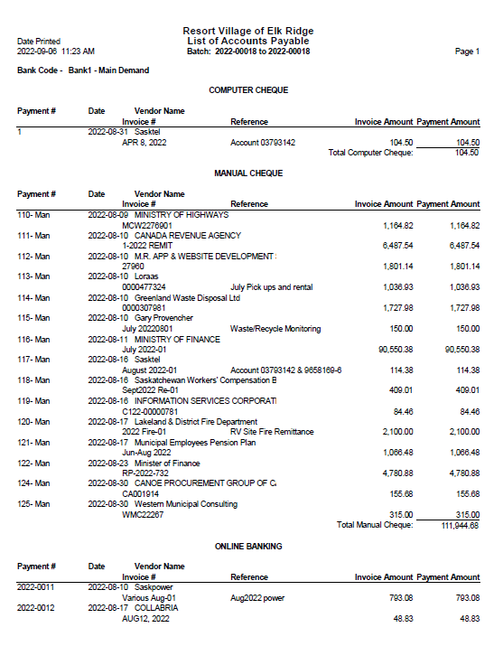

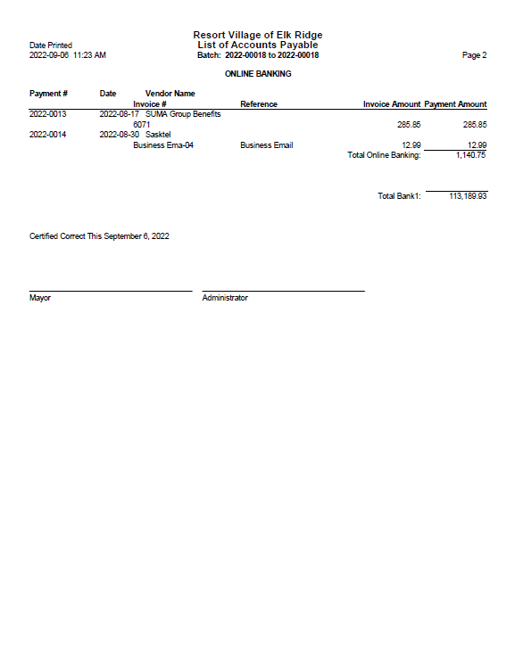

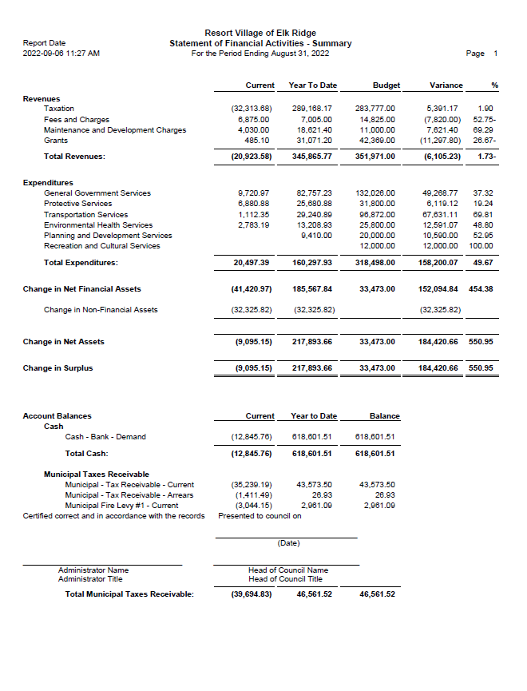

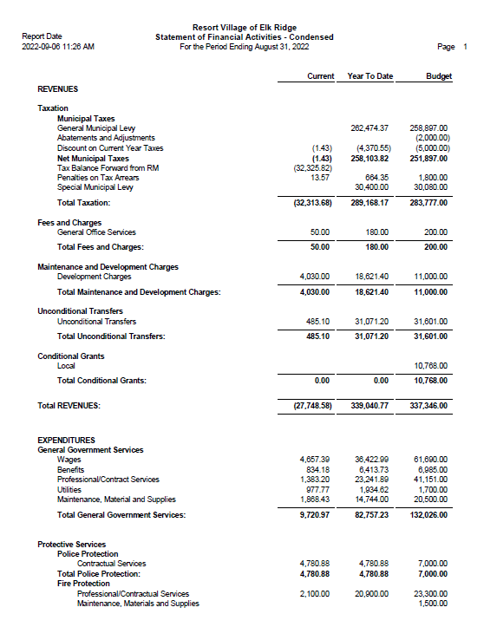

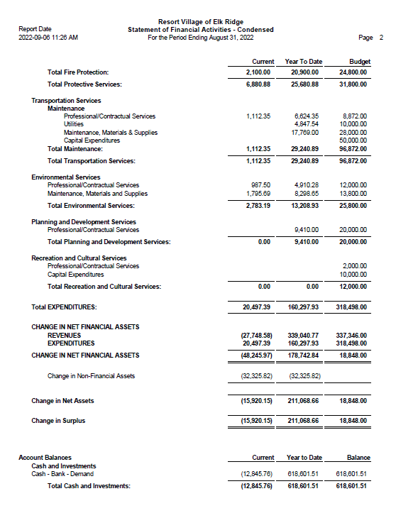

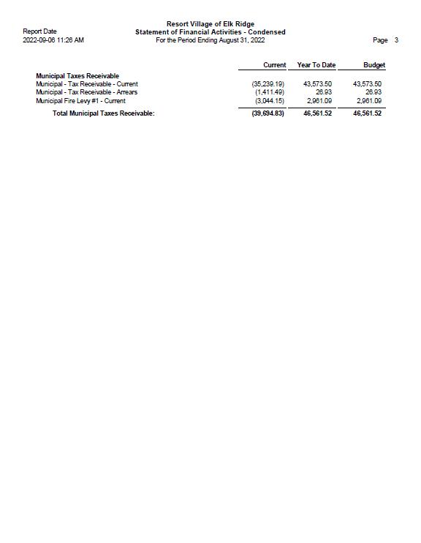

RESORT VILLAGE OF ELK RIDGE  
Bank Reconciliation August 2022

**GL 110-110-120 – General Ledger Account** **$618,601.51**

* Bank Fees -48.00
* Transfer to be recorded 1977.65

**Adjusted General Ledge Balance:**  **$620,531.16**

**Bank Account Balance at July 31, 2022 $624,532.01**

* Outstanding Cheques -4000.85

**Adjusted Bank Balance $620,531.16**

|  |  |  |  |  |  |  |  |  |
| --- | --- | --- | --- | --- | --- | --- | --- | --- |
| |  |  |  |  | | --- | --- | --- | --- | | |  |  |  | | --- | --- | --- | | |  |  | | --- | --- | | |  | | --- | | Eco-West Canada opened the next intake round to it's Electric Vehicle Charger Program (EVCP) on August 15th, 2022.   1. This program provides funding towards the purchase and installation of level 2 (240 volt) electric vehicle chargers in publicly accessible locations. 2. The program objective is to deploy 100 level 2 chargers across Manitoba and Saskatchewan.   Where can I find more information? Who is eligible? How can I apply?  Proceed to the Eco-West Canada website for further information: [https://eco-ouest.com/electric-vehicle-infrastructure-program/](https://eco-ouest.us20.list-manage.com/track/click?u=991c0074910ddd9e798c5a5ff&id=176ca739a8&e=0d91ddacaa)   1. There you will find the online application form, downloadable Application Guidebook and Form, resources to help them apply, toolkits regarding EV vehicles and FAQ's related to this particular program.   If you have any questions regarding the program or any of the documentation provided on the website, please contact:  Gaby Tétrault Liaison Officer - Eco-West Canada [gtetrault@eco-ouest.com](mailto:gtetrault@eco-ouest.com) |   **Now Open** **Electric Vehicle Charger Program Intake Round #2** | | |      |  |  | | --- | --- | | |  | | --- | |  | |      |  |  | | --- | --- | | |  | | --- | |  | | |